CEF: Cybersecurity Digital Service Infrastructure;

|  |  |
| --- | --- |
| **Version:** | **4.2.1** |
| **Date:** | **13/09/2019** |

Core Service Platform – SMART 2015/1089

**Installation Manu****al**

Contents

1 Preparatory steps 4

2 External Facing Services and Service URLs 5

2.1 Internet Facing Services 5

2.2 User Interfaces 5

2.3 Other 6

3 Requesting a Certificate via the PKI 7

3.1 Get the domain name 7

3.2 Create the private key and a CSR 7

3.2.1 Create the private key 7

3.2.2 Create the CSR 8

3.3 Submit the CSR to the PKI for signing 8

3.4 Receive the signed certificate 12

3.5 Download the Intermediate Root CA certificate 12

3.6 Download the CA bundle 14

3.7 Prepare your certificates for installation 14

4 Initial configuration 16

4.1 Importing the VM appliance 16

4.2 Connecting to the VM 16

5 Installation 19

5.1 CSP Installer health verification 19

5.2 Installation of certificates 20

5.3 CSP Instance registration 24

5.4 Download of system updates 26

5.5 Modules installation 31

6 Managing CSP 33

6.1 Starting 33

6.2 Stopping 36

6.3 Update SMTP configuration 36

7 Smoke-testing the Installation 38

7.1 Connecting via the “Single Sign-on” service 38

7.2 Connecting to individual services 40

8 Annex A: Changing settings of the VM 53

8.1 Expanding the VM root filesystem 53

9 Annex B: Jitsi VideoConferencing Bridge 55

9.1 External port accessibility 55

9.2 Bandwidth requirements 55

10 Annex C: Troubleshooting CSP Installer 57

11 Annex D: Troubleshooting the connection tunnel to the VM 59

12 Annex E: Manual Installation and configuration of the CSP Installer 60

# Preparatory steps

This installation manual is a step by step guide for the acquisition of the required certificate from the Melicertes PKI service and the installation of your local CSP.

Before proceeding to the installation please make sure that the following preparatory steps have been taken:

1. You received the hardware requirements for the CSP installation
2. You registered for a CSP installation to the central CSP authority
   1. You sent the required data and point of contact details
   2. You sent the IP address that you are going to use for your installation
   3. Your team data have been entered in the central CSP trust circles
   4. Your domain has been assigned and registered for the given IP address
3. You received an email confirming the actions in step 2 and the following:
   1. Your assigned CSP-ID.
   2. Your assigned melicertes domain in the form of <cspId>.[preprod.]melicertes.eu (e.g. cert-gr.preprod.melicertes.eu)
   3. Three manuals: Installation manual, Administration manual, User manual
   4. A link to download the base VM in OVA format, i.e. AlpineHost-v3.10-PROD.ova [1]

***Recommended requirements of the VM***

*Memory: 48 GB*

*Disk:800 GB*

*CPU:16 vCores*

*Internet connectivity*

# External Facing Services and Service URLs

The CSP instance during installation and operation will need access to the internet. The CSP instance needs to be able to initiate outgoing connections. After the installation and during operation, the CSP’s internet facing services and ports need to be accessible from the Internet. Lastly, the CSP instance provides a set of User Interfaces for its various services that need to be accessible by the users inside the organization only.

**Note**: Domains in the pre-production environment are in the form of *.<cspId>.preprod.melicertes.eu. Domains in the production environment are in the form of *.<cspId>.melicertes.eu

## Internet Facing Services

The following subdomains/ports need to be accessible from the Internet for incoming connections:

|  |  |  |
| --- | --- | --- |
| Integration Layer | https://integration.<cspId>.[preprod.]melicertes.eu | TCP 5443 (https) |
| OwnCloud | https://files.<cspid>.[preprod].melicertes.eu | TCP 6443 (https) |
| Jitsi VideoConferencing Bridge | https://teleconf.<cspid>.[preprod].melicertes.eu | TCP 6443 (https) |
| Jitsi VideoConferencing Bridge | https://vc.<cspid>.[preprod].melicertes.eu | TCP 6443 (https) |
| MISP Server Sync | https://misp-ui.<cspid>.[preprod].melicertes.eu | TCP 6443 (https) |
| Jitsi VideoConferencing Bridge – Media TCP | vc.<cspid>.[preprod].melicertes.eu | TCP 4443 (SSL) |
| Jitsi VideoConferencing Bridge – Media UDP | vc.<cspid>.[preprod].melicertes.eu | UDP 10000 |

**Important Note:** For further details on Jitsi VideoConferencing Bridge network considerations please continue toAnnex B: Jitsi VideoConferencing Bridgebefore progressing further**.**

While Videoconferencing (Jitsi) and file sharing (OwnCloud) need to be generally open (ports 6443, 4443, 10000 UDP), Integration layer only needs to be accessible by the rest of the CSP instances (port 5443).

## User Interfaces

The following subdomains/ports need to be accessible only from within your organization:

|  |  |  |
| --- | --- | --- |
| Trust Circles | https://tc.<cspId>.[preprod.]melicertes.eu | TCP 443 (https) |
| OpenAM Admin. | https://auth.<cspId>.[preprod.]melicertes.eu/openam | TCP 443 (https) |
| Search (Kibana) | https://search.<cspId>.[preprod.]melicertes.eu | TCP 443 (https) |
| Logs (Kibana) | https://logs.<cspId>.[preprod.]melicertes.eu | TCP 443 (https) |
| Sharing Policies | https://integration-ui.<cspId>.[preprod.]melicertes.eu | TCP 443 (https) |
| Anonymization | https://anon-ui.<cspId>.[preprod.]melicertes.eu | TCP 443 (https) |
| Request Tracker (RT) | https://rt.<cspId>.[preprod.]melicertes.eu/RTIR | TCP 443 (https) |
| MISP | https://misp-ui.<cspId>.[preprod.]melicertes.eu | TCP 443 (https) |
| Jitsi VideoConferencing Bridge Admin. | https://teleconf-ui.<cspId>.[preprod.]melicertes.eu | TCP 443 (https) |
| InteMQ Manager | https://imq.<cspId>.[preprod.]melicertes.eu | TCP 443 (https) |
| Viper Manager | https://viper-ui.<cspId>.[preprod.]melicertes.eu | TCP 443 (https) |

Note: You can bookmark the above links after replacing the correct <cspId> and adding/removing “preprod” from the URL depending on the environment.

## Other

SSH should be accessible only from within your organization:

|  |  |  |
| --- | --- | --- |
| SSH | <cspId>.[preprod.]melicertes.eu | TCP 22 |

# Requesting a Certificate via the PKI

The following text describes the steps to be taken for a CSIRT to obtain a signed certificate for the 'melicertes.eu' domain.

The generic steps are:

1. Get the domain name
2. Create a private key and a CSR
3. Request a signed certificate from the CSR
4. Receive the signed certificate
5. Obtain the Intermediate Root CA certificate

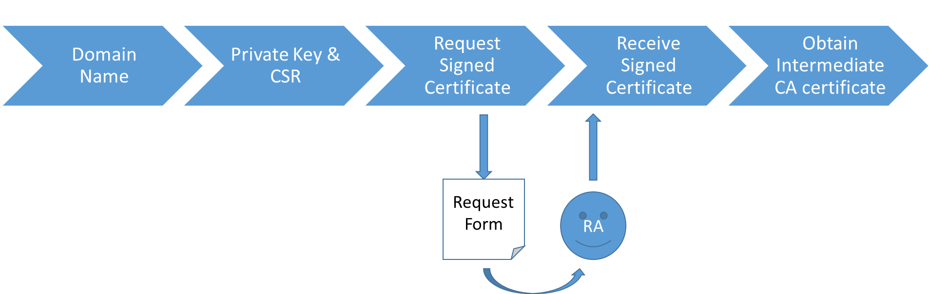

## Get the domain name

The Domain Name that you can use within the context of the MeliCERTes platform will have been determined during the application procedure.

For the remainder of this text, we’ll work with the dummy domain name ‘bari.test.melicertes.eu’ for the examples. The certificate will be for a wildcard: *.bari.test.melicertes.eu.

## Create the private key and a CSR

The commands below assume you use OpenSSL for creating the private key and CSR. As a convention, the domain name is used as a filename for reasons of clarity.

### Create the private key

Execute the following command:

|  |
| --- |
| openssl genrsa -out bari[2].test.melicertes.eu.key 2048 |

Output will be similar to:

|  |
| --- |
| Generating RSA private key, 2048 bit long modulus  .........................................................+++  .............................................+++  e is 65537 (0x10001) |

The result will be a file named bari.test.melicertes.eu.key.

***Important Note***

*You should* ***not*** *generate a private key with a passphrase. MeliCERTes currently does not support this and the reverse proxy installation will fail*

### Create the CSR

Execute the following command (substitute the determined domain name for the value of the ‘CN’ field):

|  |
| --- |
| openssl req -new -key bari.test.melicertes.eu.key -out bari.test.melicertes.eu.csr -subj "/CN=*.bari.test.melicertes.eu/O=MeliCERTes-MCERTS/C=EU/DC=eu/DC=melicertes" |

The command does not give output.

The result will be a file named bari.test.melicertes.eu.csr.

## Submit the CSR to the PKI for signing

Go to “<https://pki.dfn-cert.de/melicertes-ca/cgi-bin/pub/pki><https://pki.dfn-cert.de/melicertes-ca/pub>”. The Welcome screen is shown. Select “Server Certificate” on the “Certificates” tab.

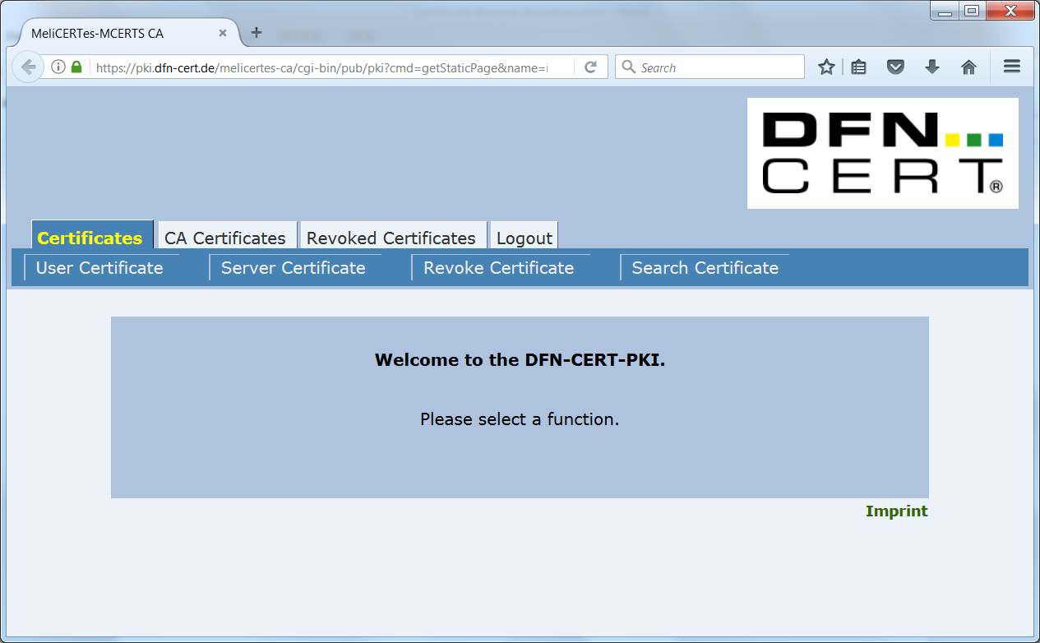

Select “Server Certificate” on the “Certificates” tab.

The “Request a Server Certificate” screen is shown.

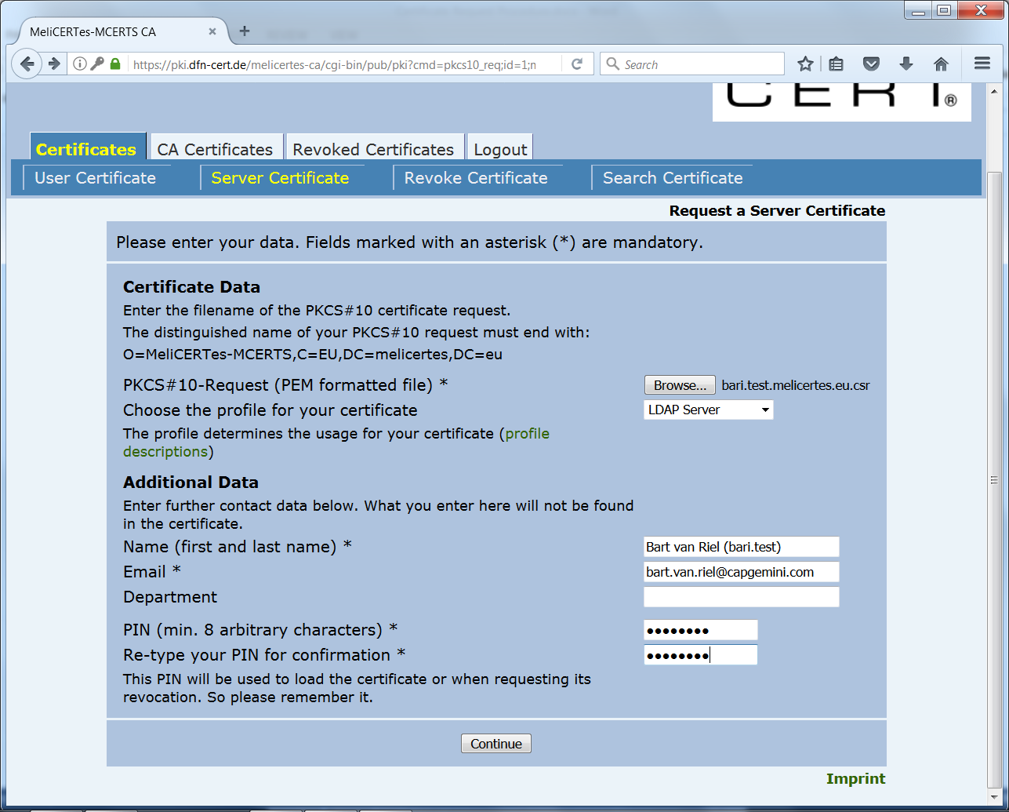

1. Select the CSR file with the “Browse… button”.

2. Choose “LDAP Server” as the profile (this will ensure you get a certificate which can be used both for mutual service authentication and for serverside encryption within your installation later on).

3. Fill in the Name and Email fields (these will be used to validate the signing request AND communicate the results).

4. Choose a PIN which is easy to remember (it is needed to work with the certificate later on).

5. Click “Continue”.

The “Request a Server Certificate - Confirmation” screen is shown.

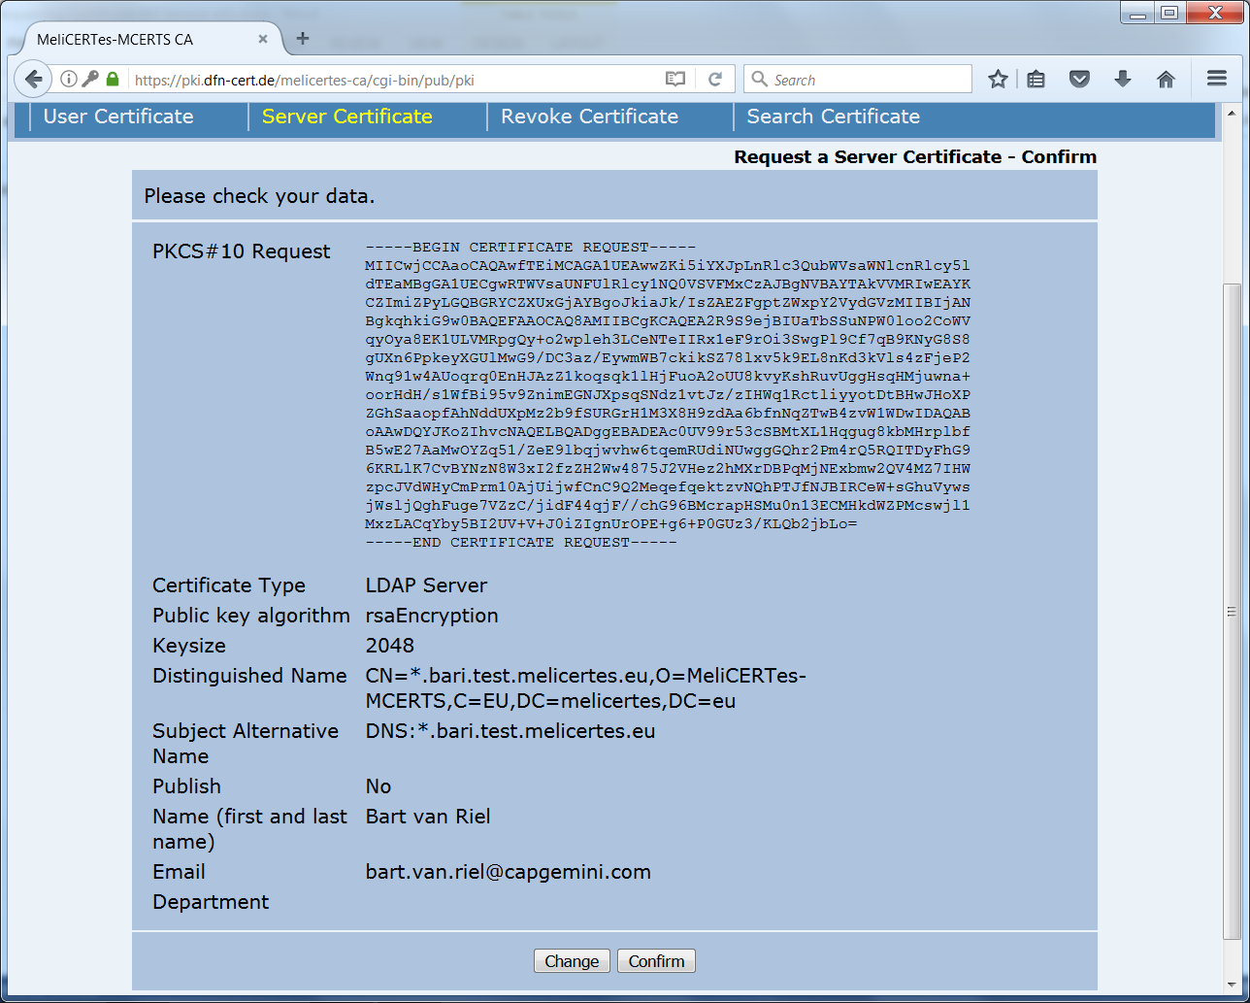

Validate the information on it. If anything is out of order, click “Change” and you will be taken back to the “Request a Server Certificate” Screen. I everything is Ok, click “Confirm”.

The “Certificate Request” confirmation screen is shown. Your request has now been recorded. However, additional paper validation by the Registration Authority (RA) is needed.

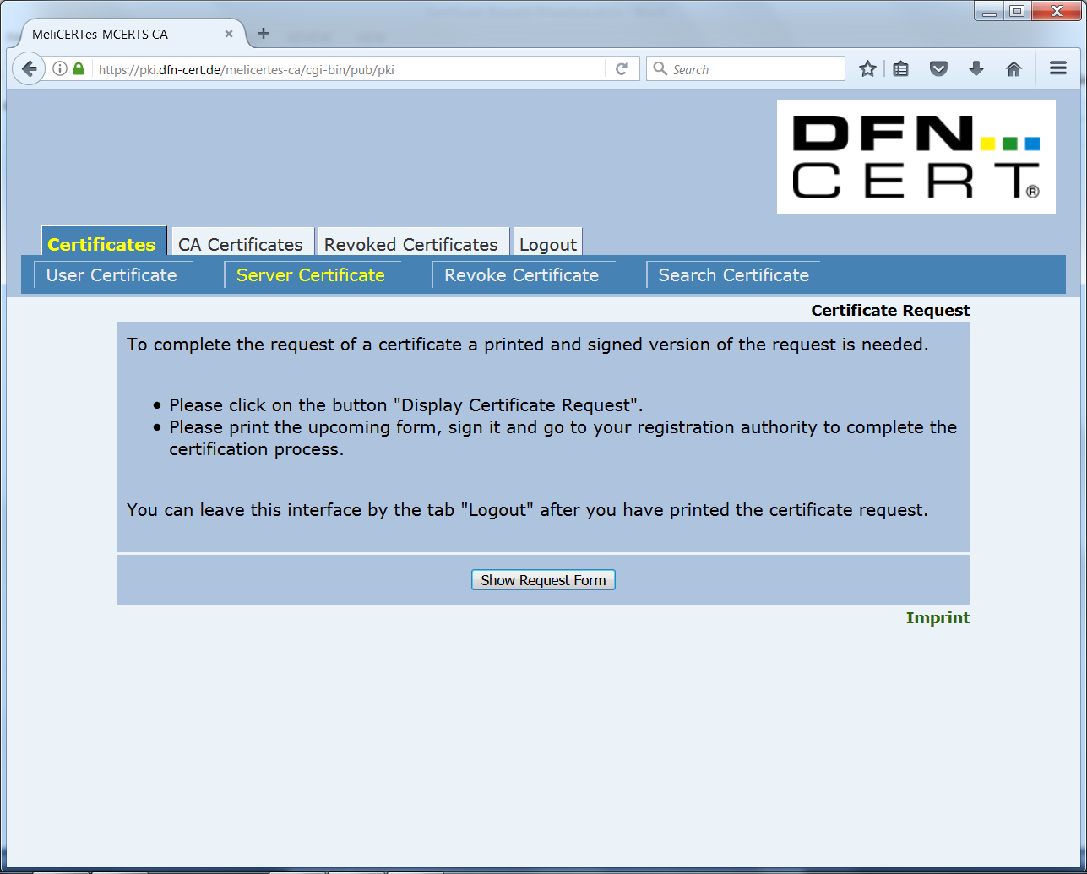

Choose “Show Request Form”, print the resulting PDF file, fill out the necessary details and submit the filled out and signed form (in scanned electronic form) to the helpdesk as a “service request”. As a subject please enter: “Server Certificate Request - <cspId>”.

## Receive the signed certificate

After the certificate request has been approved by the RA, you will receive an email containing the certificate as attachment (in the form of a *.pem file). Store the certificate as desired.

You will also need a copy of this file with the extension “.crt” for the installation procedure. Copy the .pem file and rename it with the “.crt” extension (e.g. “Signed SSL Certificate.crt”).

## Download the Intermediate Root CA certificate

Click on the deeplink for “importing the CA certificate” which is in the e-mail which included the certificate. The “CA Certificates” tab of the PKI site is shown.

Click on the tab “CA Certificates” and then choose “Certificate of MeliCERTes-MCERTS CA”. 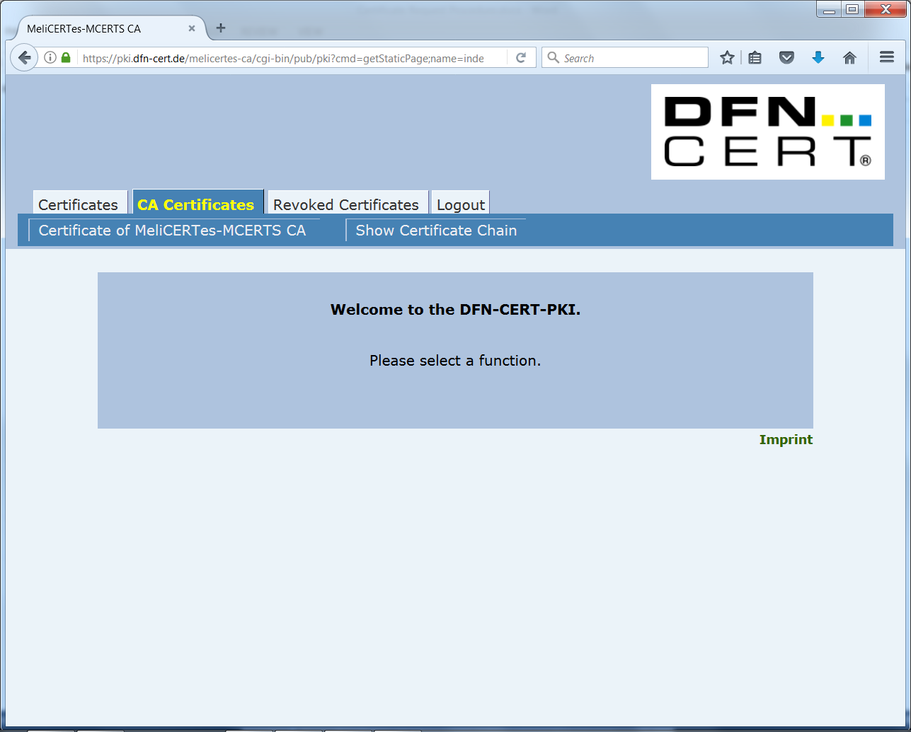

In the resulting dialog box, select all checkboxes and click “OK”.

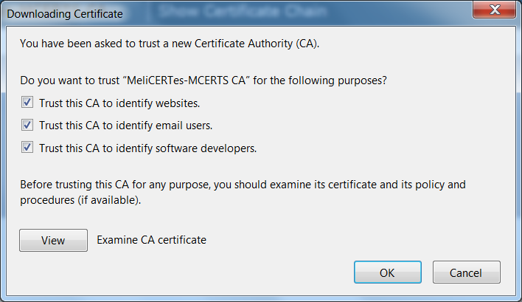

The CA certificate is now silently installed into the webbrowser. To retrieve it, it needs to be exported.

For Firefox, perform the following steps:

* Go to the “Options” page via the menu
* Choose “Advanced”→”View Certificates”
* Under “Authorities”, find the “MeliCERTes-MCERTS” entry and select the “MeliCERTes-MCERTS CA” certificate
* Choose “Export…” and save the certificate where desired.

## Download the CA bundle

Click on the tab “CA Certificates” and this time choose “Show Certificate Chain”

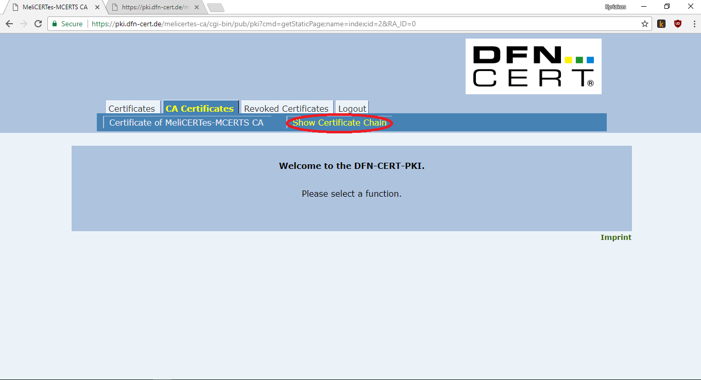

A new tab will open with the certificate chain. Copy **only** the text starting with “-----BEGIN CERTIFICATE-----” and ending with “-----END CERTIFICATE-----” as shown in the picture below. Make sure you leave the first line out. Paste the text to a text file and save the file with the extension .crt (e.g. “CA Bundle.crt”). You will be needing this file for the installation.

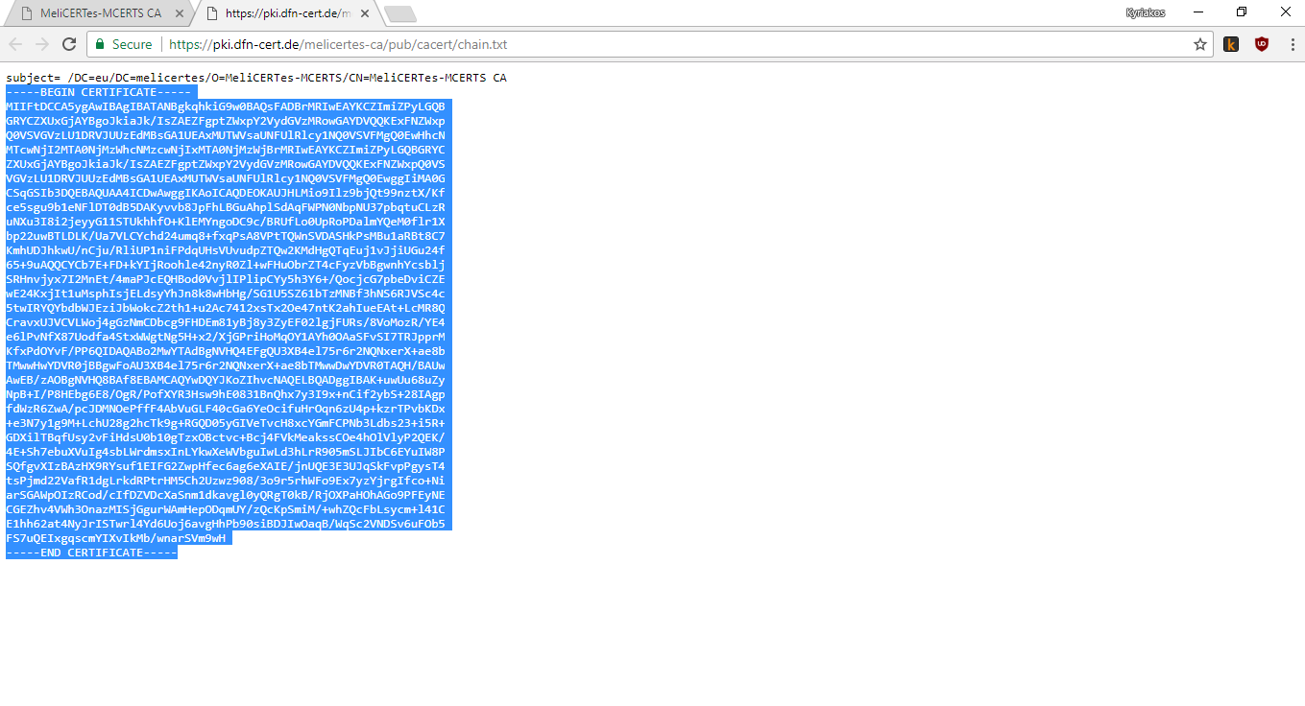

## Prepare your certificates for installation

During installation you will need the following 3 files

1. The CA Bundle that you created in section 3.6. File extension “.crt”. File name “CA Bundle.crt”
2. The signed SSL certificate that you got in section 3.4. File extension “.crt”. File name “Signed SSL Certificate.crt”
3. The private key that you created in section 3.2. File extension “.key”. File name “Private SSL Key.key”

# Initial configuration

## Importing the VM appliance

An Open Virtualization Archive (OVA file) has been distributed and contains the original VM for this project. Please do note that it is versioned, and you may need to update it if instructed. This OVA has settings for memory and CPUs that need to be adjusted, according to specifications previously communicated. It is advised that the administrator importing the file proceeds with such modifications prior to the installation steps mentioned below. In the case of the ESXi "Import from OVA..." option, the ESXi system prompts to modify settings before the machine boots. More detailed information can be found in Annex A: Changing settings of the VM.

**Important**: the OVA has *very low memory and CPU* configuration and **is not possible to complete the installation successfully** using the defaults. Please refer to Annex A: Changing settings of the VM for instructions on how to resize the VM to proper size for CSP use.

## Connecting to the VM

When the guest machine boots, the user should connect via SSH to the guest machine while at the same time creating an SSH tunnel between the guest machine and their computer. This is necessary so the user web browser can access the GUI installation.

This can be accomplished using either a GUI SSH client such as PuTTY or a Linux terminal. The SSH server listens to the default port (22). The default machine credential for user root is “systempass”. It is advised that the administrator changes this immediately after first login. The SSH tunnel essentially allows the user to access a port on the guest machine over SSH. The port that needs to be accessed on the host machine is 18080. For simplicity, it will be mapped to local port 18080 but the user can choose otherwise.

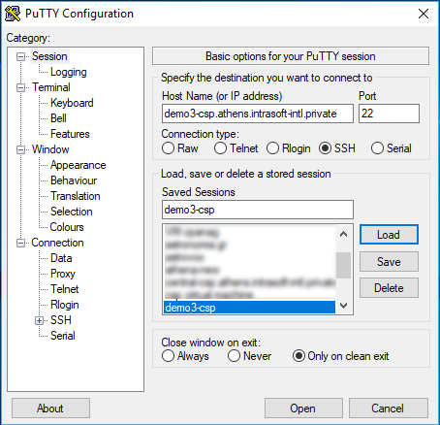

In the case of using **Putty**, the user should enter guest machine hostname and port 22 in the initial screen (session) then save the SSH connection as a session. The user must then use the left-side panel and navigate to “Tunnels”. The user should enter 18080 to Source port and localhost:18080 to the Destination and then click the Add button. By clicking the “Open” button a new connection is made. The user should login using the root credentials mentioned above and Putty will auto-create the tunnel.

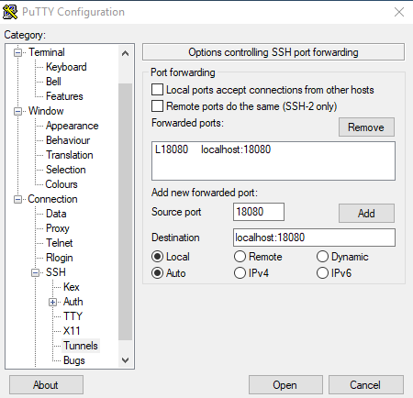

In the case of using a Linux terminal, the SSH connection with the tunnel can be created using the following command format:

|  |
| --- |
| ssh root@<guestmachinehostname> -L 18080:localhost:18080 |

where <guestmachinehostname> is the hostname or IP of the guest machine.

The system will request the root password. After entering the root password, the user is logged in to SSH and the tunnel has been created.

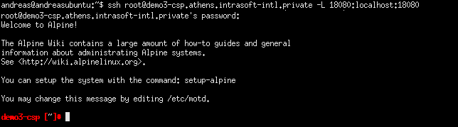

Please note that in both the case of Putty and the terminal SSH client, first-time connections to the guest machine will present a prompt to confirm the authenticity of the host. The user should accept the presented key and the notification will not be presented again when using the same client on the same computer.

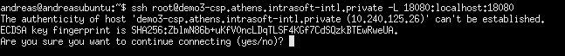

# Installation

## CSP Installer health verification

At this point it is important that you have been connected to the VM via SSH by also opening a tunnel to port 18080, as already mentioned in paragraph 4.2. You can do so by executing the following command in your terminal:

* ssh root@<guestmachinehostname> -L 18080:localhost:18080

After succesfull login you may ensure that everything is OK by checking the log file of the CSP Installer, by executing the following command:

* fgrep -e "connect" -e "Connected" /tmp/console.log

and verify that CSP Installer reports:

* connectivity to config.central.<cspId>.[preprod.]melicertes.eu:5443
* connectivity to Internet
* connectivity to google.com:443

The above may look like the following snippet, as an example:

* Attempting to connect to google.com:443
* Connected to google.com:443
* Attempting to connect to config.central.demo.melicertes.eu:5443
* Connected to config.central.demo.melicertes.eu:5443
* Internet connectivity test has completed, connection is OK

After successful SSH login, as mentioned above, the user can now use the graphical CSP installation control application tool through their local computer web browser by entering the following URL: http://127.0.0.1:18080.

*The SSH connection should be kept alive always for the tunnel to work. If the SSH connection is closed then the web application will not be available and the user should reconnect via SSH with the tunnel to port 18080*

After starting the graphical CSP installation tool by opening the URL http://127.0.0.1:18080 in a web browser, the user is presented with the dashboard. Please, visit section 11 - Annex D: Troubleshooting the connection tunnel to the VM, in case you encounter issues in accessing the aforementioned URL.

First time installation should display a progress of 0%. The menu bar at the top of the page displays the basic operations of the application which are “Dashboard”, “Installation”, “Updates” and “System”. These options should be selected at the order instructed in this manual. A brief description of what each option does is as follows:

“Dashboard”: Displays overall progress and general information. This page will be further enhanced in later releases to show system status.

“Installation”: Performs a one-time installation/configuration of the CSP.

“Updates”: Downloads and updates component images and offers access to the log.

“System”: Starts and stops the system and displays the status of all services.

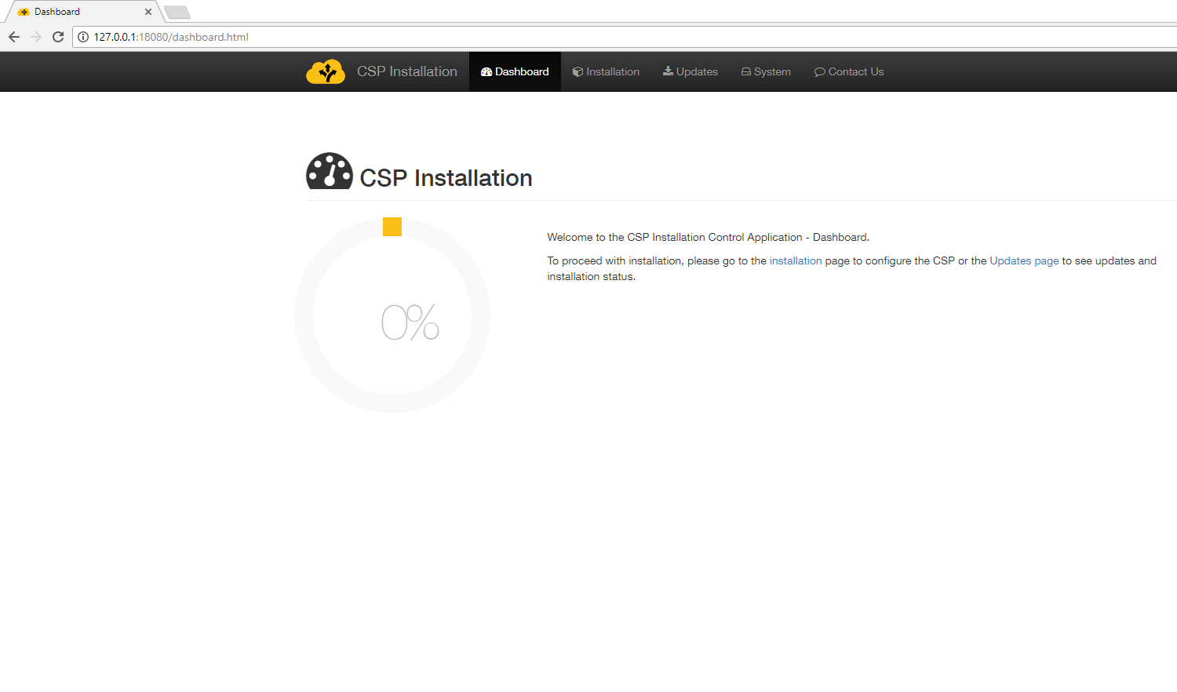

The first time the CSP installation control application is accessed, the user should proceed to the **Installation** page in order to perform initial configuration.

## Installation of certificates

Completing the first installation step requires that the user has saved to his computer all certificate and key files required as mentioned in the previous sections of this manual. The necessary certificates are the CA bundle, the Private SSL Key and the Signed SSL certificate. The file names can be found in section 3.7. The user should make sure that he has them stored in a location that is easy to locate once he hits the Browse button.

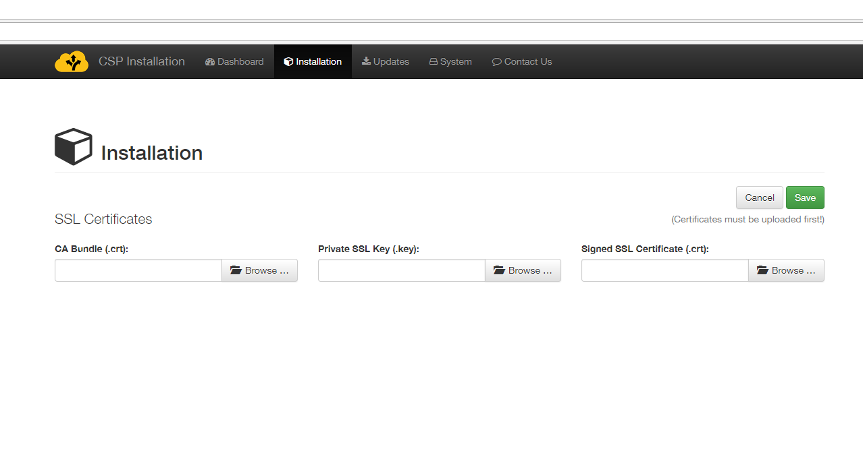

The user should browse and select the files in the order given. First, the user should click the “Browse” button for the CA Bundle certificate and select the “CA Bundle.crt” file. Once selected, the name of the file will appear in the box.

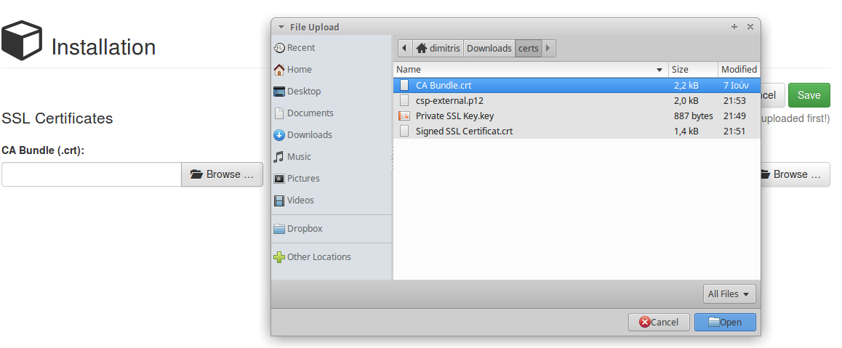

Then the user should click the “Browse” button of the Private SSL Key and select the “Private SSL Key.key” file. Once selected, the name of the file will also appear in the box.

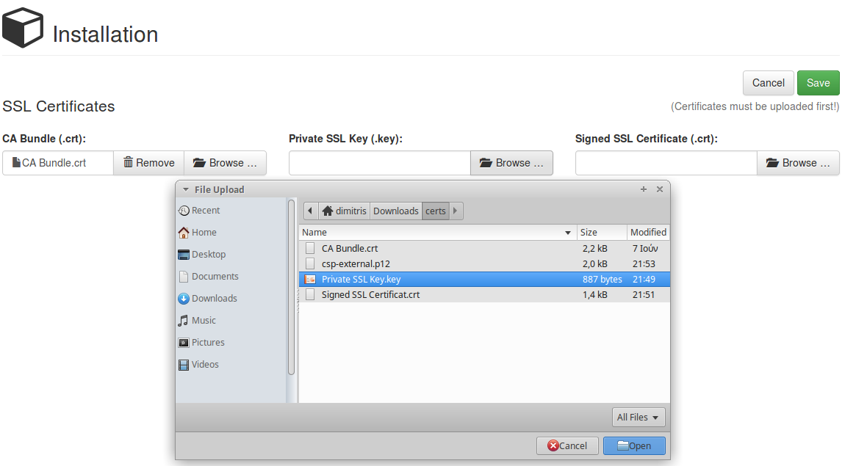

Finally, the user should click the third “Browse” button of the Signed SSL Certificate and select the “Signed SSL Certificate.crt” file. Once selected, the name of the file will also appear in the box.

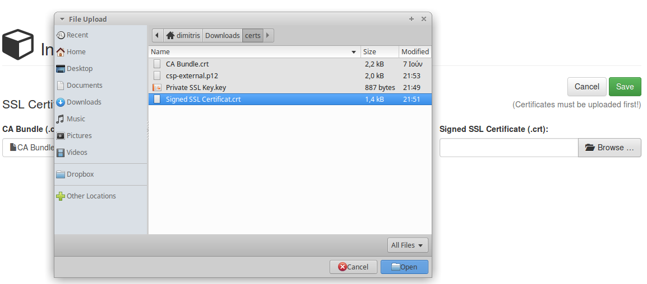

Once all three files have been selected, the user should click on the green “Save” button. Prior to uploading the files, the system will prompt the user for confirmation. By clicking the upload button, the system will upload the certificate files and redirect the user to the registration page.

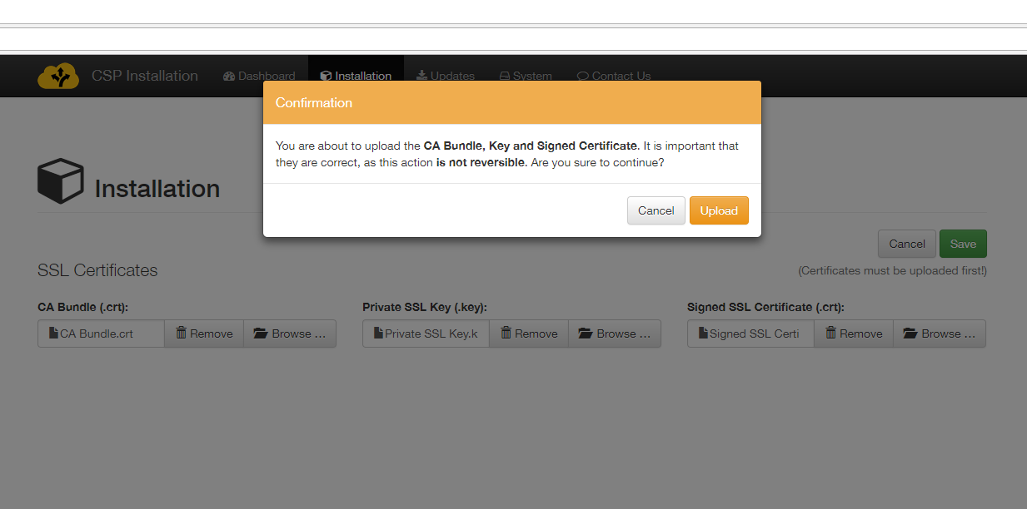 Incomplete submittal of the certificates is not possible. The system will alert the user that certificate files are missing if the Save button is clicked and not all three files have been selected.

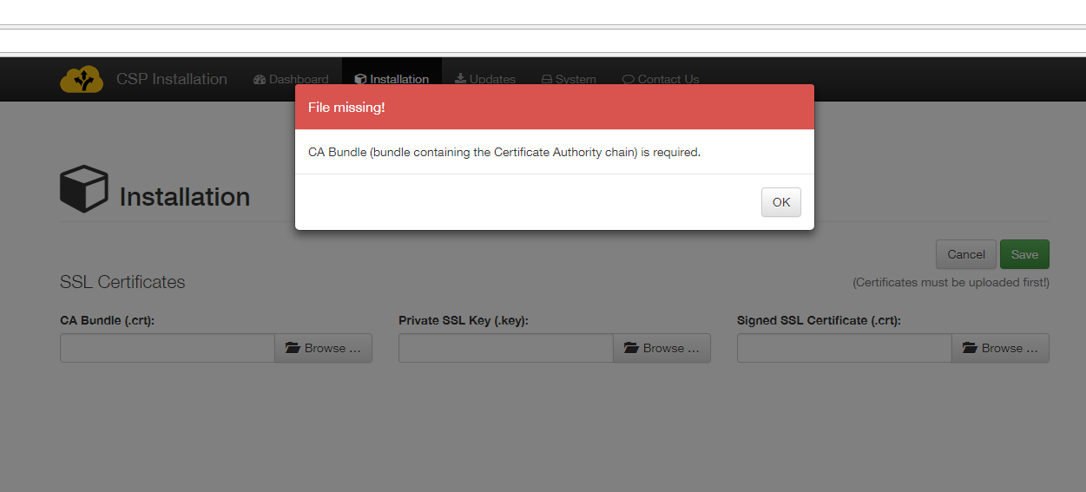

## CSP Instance registration

In the Registration page, the user must enter basic CSP information that includes CSP-ID, Domain, Responsible contact info, internal/external IP’s and SMTP configuration for outgoing e-mails.

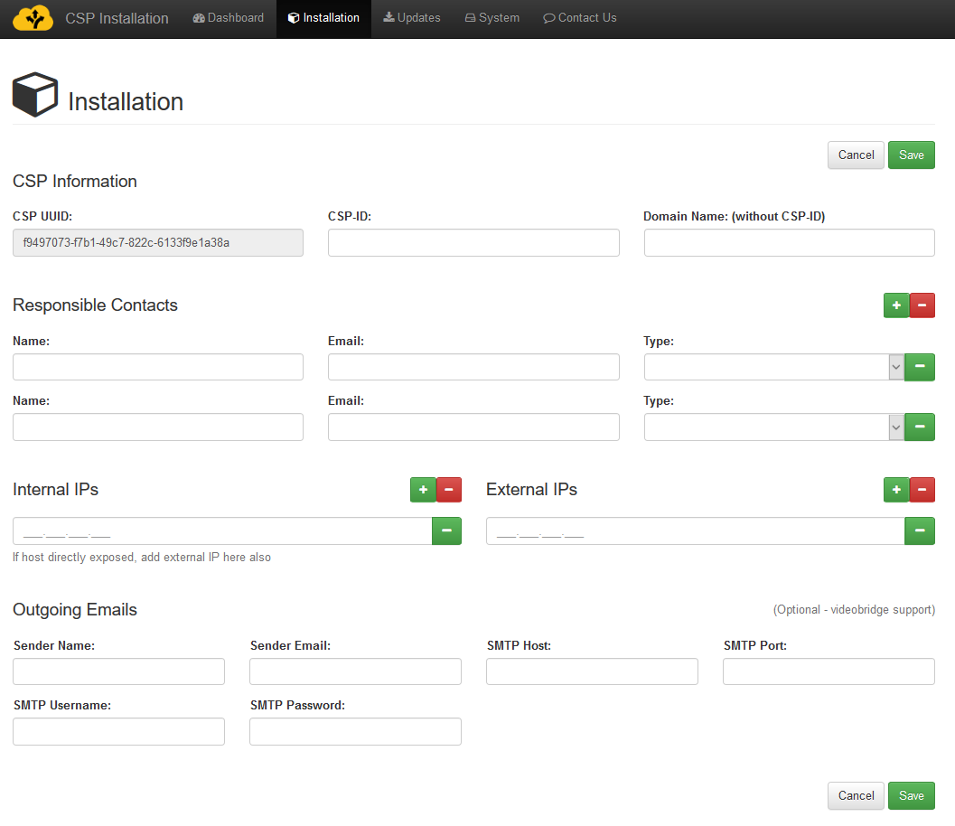

This form is protected against incomplete submission. If the Save button is clicked without all required fields completed, warning will be displayed.

The fields of this form should be completed as follows.

**CSP UUID**: This field is auto completed by the system and is the Unique Identifier of the CSP instance.

**CSP-ID**: The assigned CSP id (e.g. “csirt-gr”)

**Domain Name**: The domain (without CSP-ID) as determined by the application procedure and environment (e.g. preprod.melicertes.eu). Note: the CSP-ID and Domain name should be already known. If the user doing the installation does not have them, the registration procedure will fail.

**Responsible Contacts**: At least two contacts must be provided. For each contact, the full name and email of the person listed as contact are needed as well as the type (e.g. Tech Admin). More contacts can be input by adding lines to the form using the green + button.

**Internal/External IPs:** The internal and external IP’s of the guest machine need to be inserted. Please note the following details:

1. If the system is directly outside the firewalls (e.g. DMZ or direct access to the internet) then Internal IP entered should be the same as external IP, as provided by the network administrator.
2. If the system is behind a NAT firewall, the Internal IP should be the IP of the system inside the corporate network. The external IP should be the one used to exit the firewall (public IP address) and it should be static (not dynamic external IP). If the administrator cannot allocate a specific IP via NAT, it is advised this machine to be put on a DMZ instead.
3. Only one internal IP and only one external IP are supported.

All the above fields are **mandatory**.

The final section of the form, Outgoing Emails (Optional – videobridge support), is optional and there be no warning if it not completed. This section consists of an SMTP server configuration options, namely:

* Sender Name
* Sender Email
* SMTP Host
* SMTP Port
* SMTP Username
* SMTP Password

The videoconferencing administration requires a valid SMTP configuration so it is suggested that these details are filled in – a simple Gmail account may be used if no “real” account is available. Not entering the SMTP details will make the bridge lose the ability to send out invitations/cancellations to the scheduled conferences and together with them, the assigned username/password and bridge conference room details.

A sample filled in form appears below.

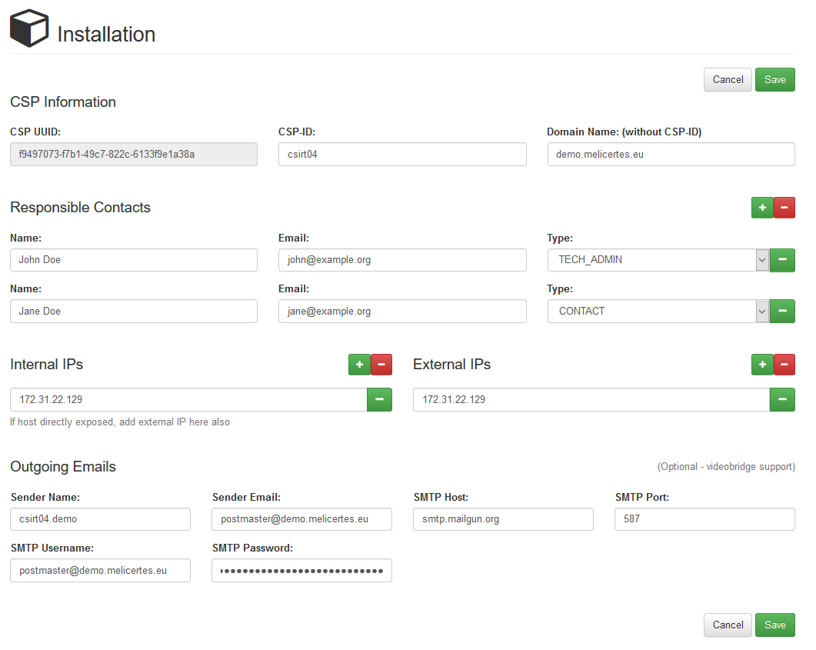

The form is submitted by clicking the green Save button.

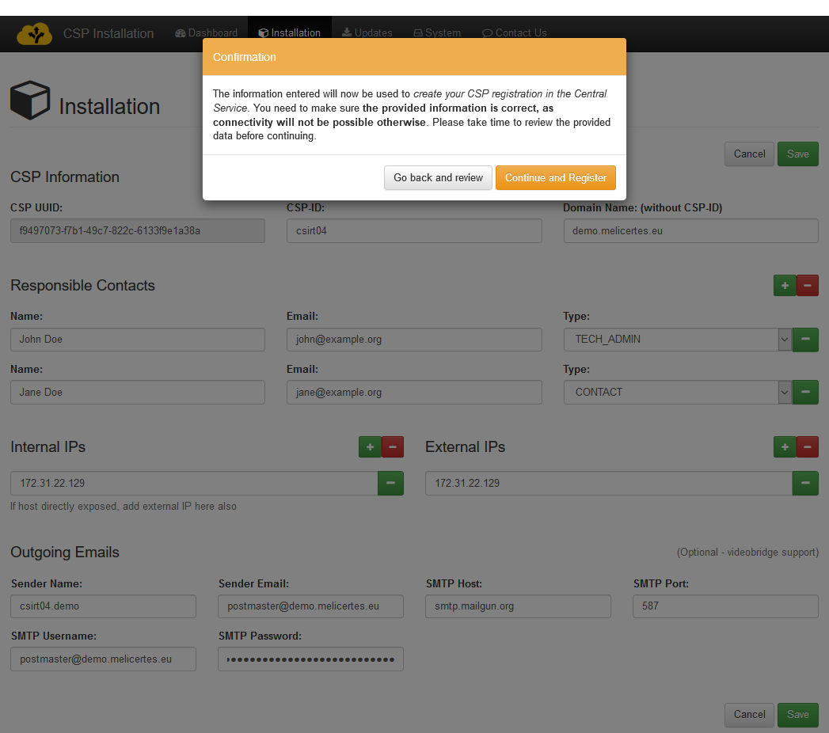

The system prompts for confirmation prior to final submission. It is important that all information entered is correct since connectivity will not be possible if any misspellings exist in the CSP name, domain and IP’s. After pressing the “Continue and Register” button, the system will redirect to the Dashboard page.

At that point, the installation UI performs a CSP registration action and on completion, assumes the CSP as registered. **The user should contact the operators of the central CSP to inform them about the new CSP registration.**

## Download of system updates

In a new installation, a registered CSP is not operational yet. **Specific actions are necessary on the central CSP side to allow this new CSP to receive updates and continue the installation**. The user should proceed to the “Updates” page. The updates list should be empty until the operators of the central CSP assign updates to this CSP instance. Once the updates are assigned, the list will be populated, and the user can continue with the installation.

In an existing installation, updates may appear on the “Updates” page periodically. This page should be checked once a week during a scheduled maintenance window.

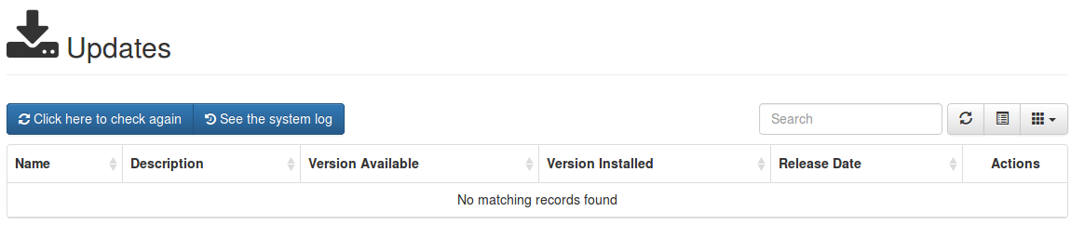

The user can check for updates by selecting the “Click here to check again” button. The CSP does not display *any updates on this page* until updates are assigned. The updates list will appear as below, in a configured CSP:

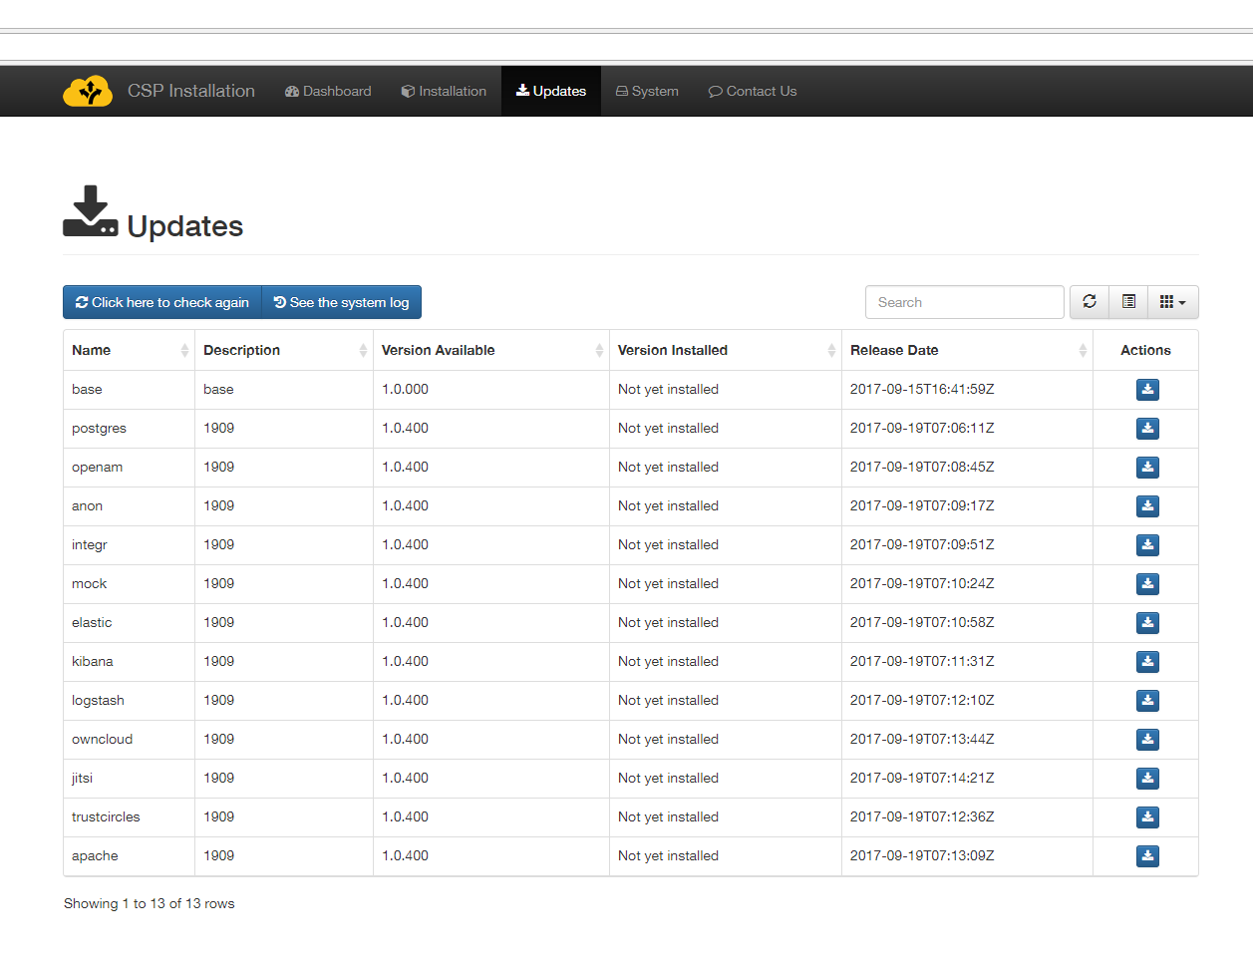

The user can download updates by clicking on the blue download icon in the Actions column. Each time the user clicks on a download button, the system will redirect them to the System log page.

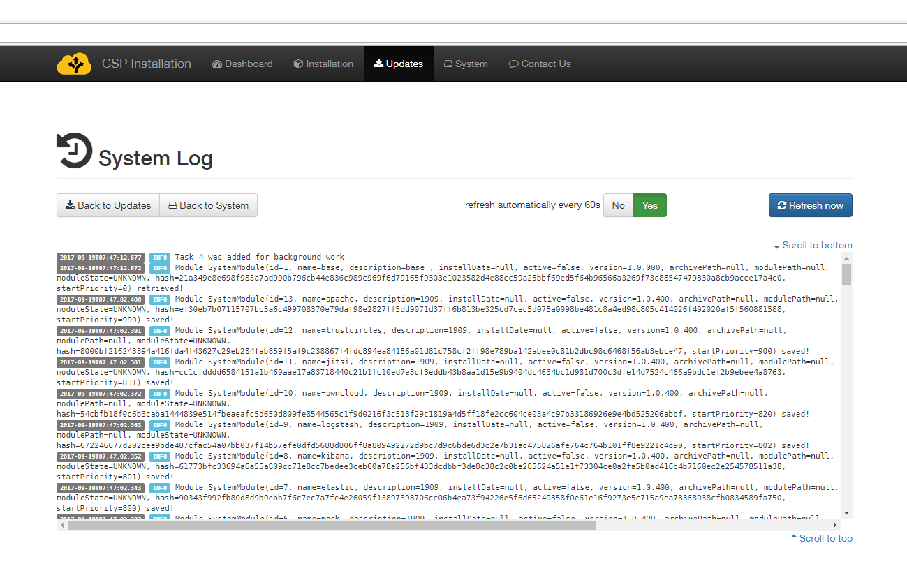

Most operations, including downloading of updates takes place in the background so the user can return to the Updates page by clicking the “Back to Update” button, and page refresh (for updated log entries) happens every 60 seconds or if the “Refresh now” button is pressed.

An indicative list of log entry extracts with explanations follows:

* “Task X was added for background work” – the system has scheduled an operation to happen in the background. Expect further information after 5-8 seconds.
* “BackgroundTaskResult(success=true, errorCode=0, moduleName=<variable>)” – indicates a successfully executed operation
* “BackgroundTaskResult(success=false, errorCode=<variable>, moduleName=<variable>)” – indicates a failed operation. The logs should be returned to the support team for further investigation[3].

Note that updates that are currently downloading will present an animated gear icon in the “Actions” column.

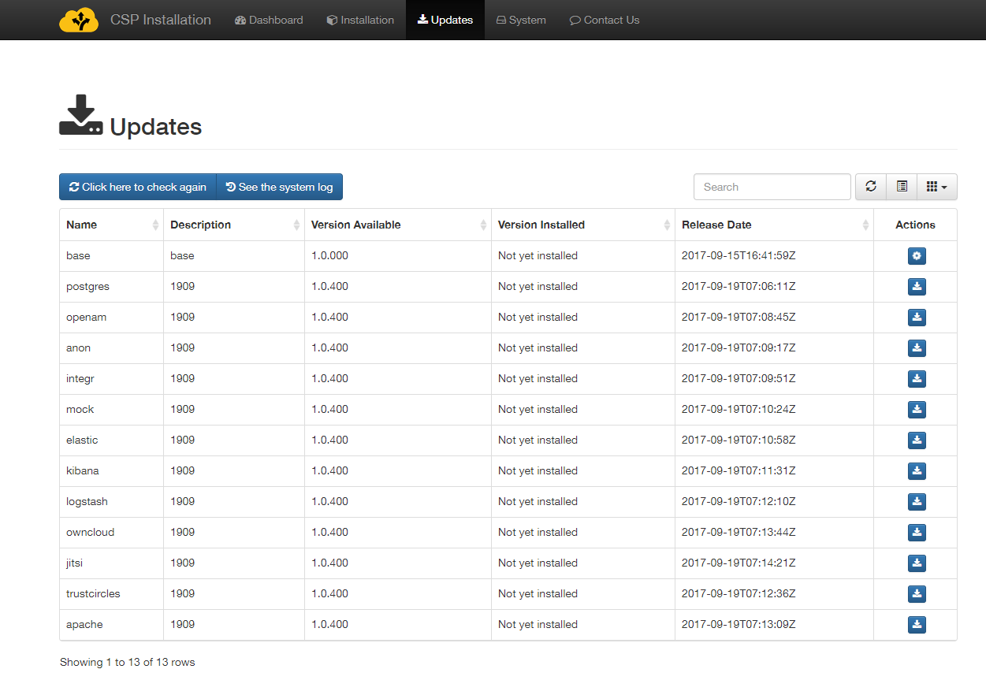

The user may request more downloads without waiting for the previous ones to finish as all download requests are added as background tasks. Completed downloads will present two new icons in the Action page, the green Install icon and the red delete icon. Note that although possible, clicking the download button multiple times should be avoided. You may monitor the download process by pressing the “Refresh” button on the button bar over the “Actions” column, without leaving this page.

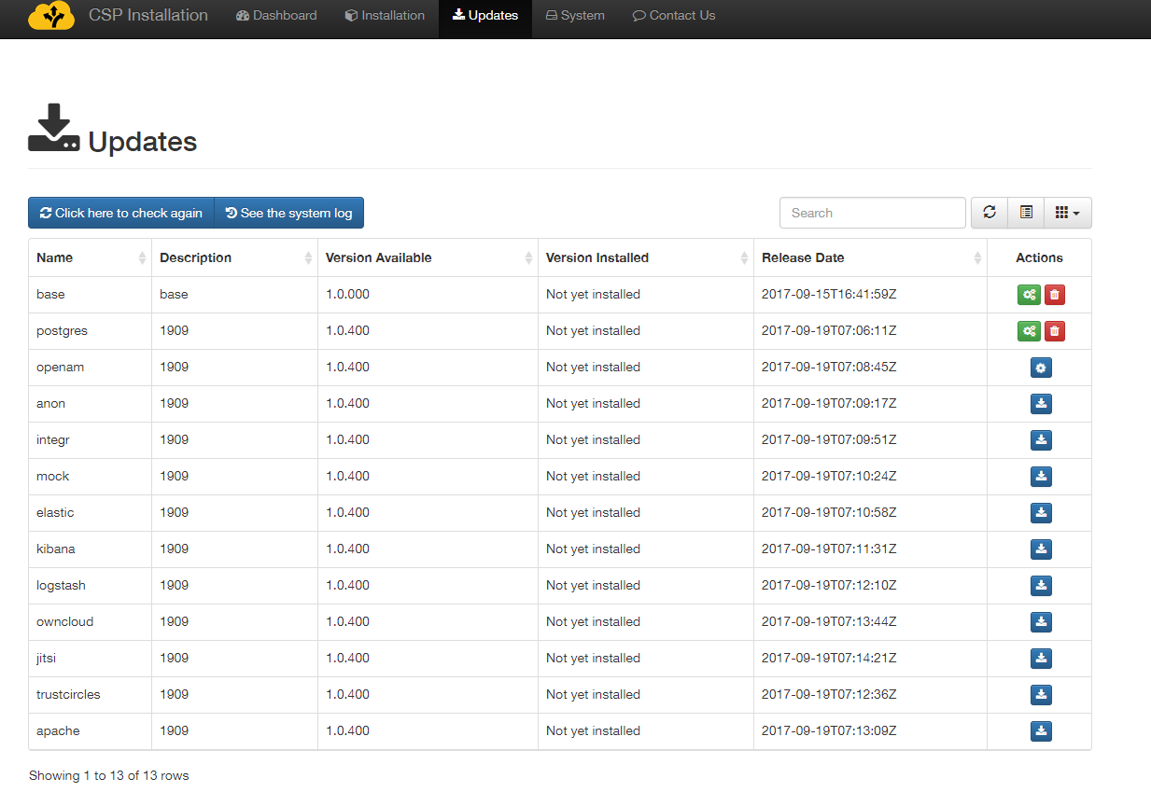

All available updates should be downloaded reaching the stage where all images are available for installation as shown in the following image.

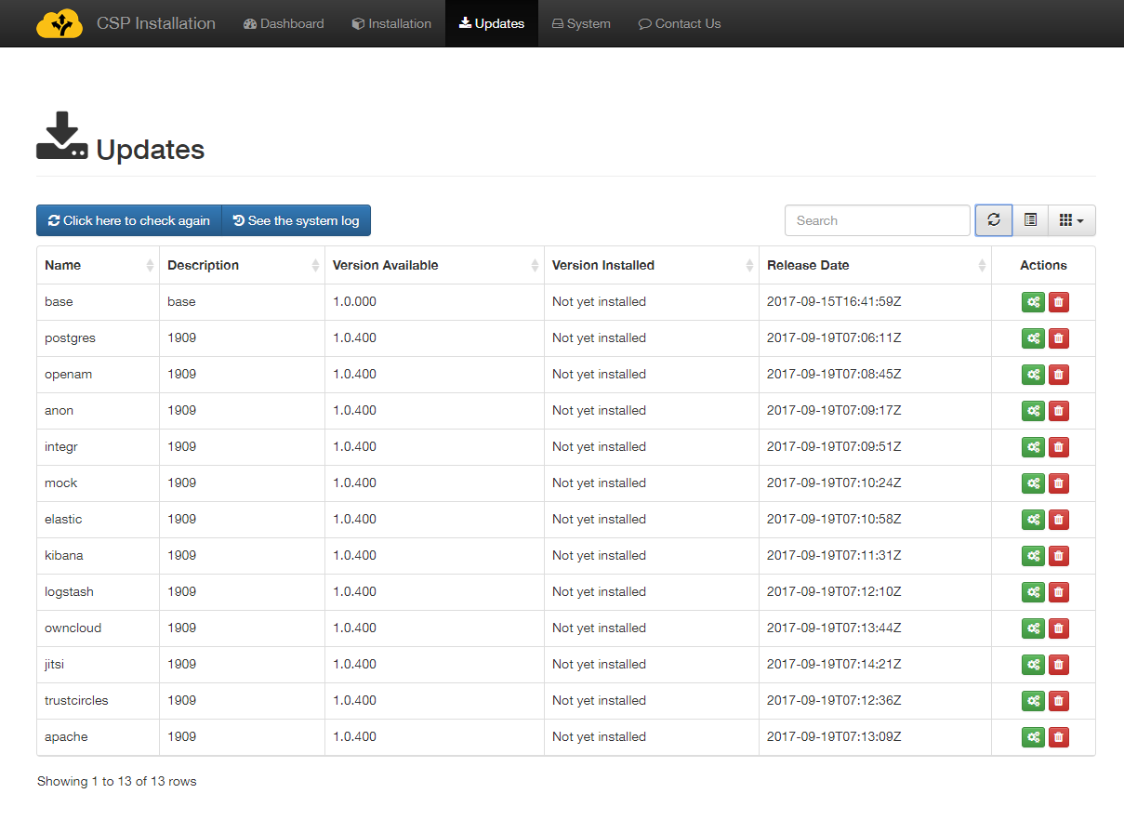

## Modules installation

Now, component installation should begin. By clicking the green Install icon for each image, the user should install ALL available images, by consecutively clicking the install buttons, for the system to properly function.

By clicking the install button for an image, the user is redirected to the System log where they can monitor installation progress. The installation process for some modules may take more than 5 minutes, as there is an implicit setup phase that happens. The process may be monitored at the system log page. The user should expect a log entry with “BackgroundTaskResult” indicating “success=true”.

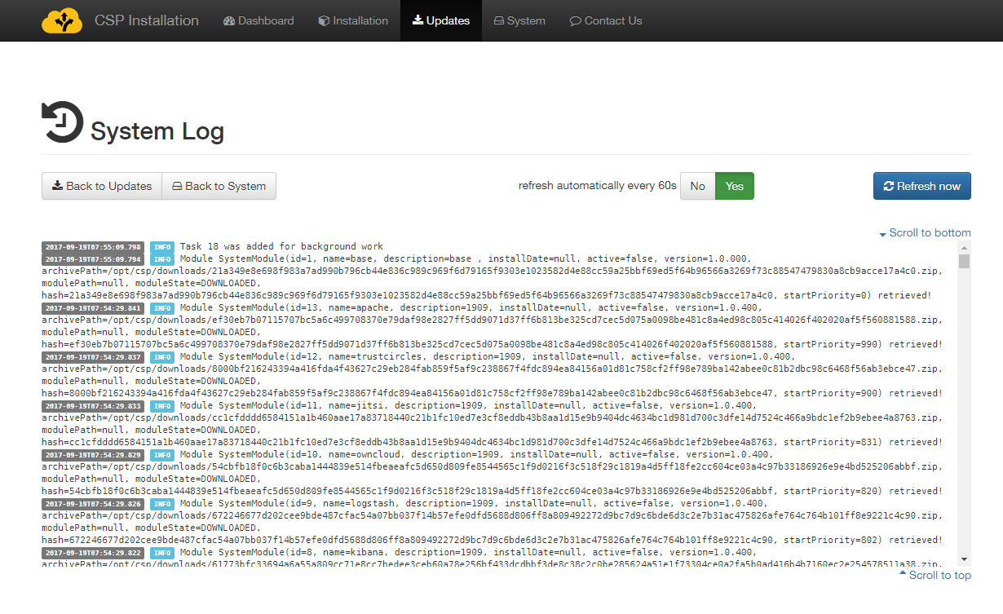

Image installations should not be performed concurrently. User should wait till the installation of each image completes successfully before proceeding to the next image installation. Please note that *while an image installation is taking place, nothing appears in the Action column* for the module being installed, as shown in the figure below.

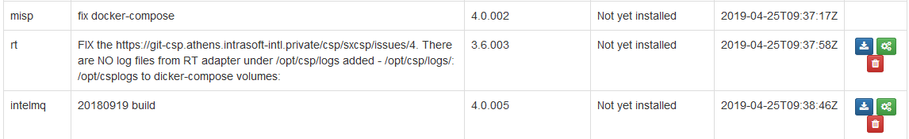

When an image installation is finished:

* a yellow Re-install icon appears in the Actions column. This should only be selected if specific circumstances mandate re-installation of an image, or if explicitly requested by the support team.
* a red Delete icon appears in the Actions column. This should be selected if the corresponding module no longer is required.

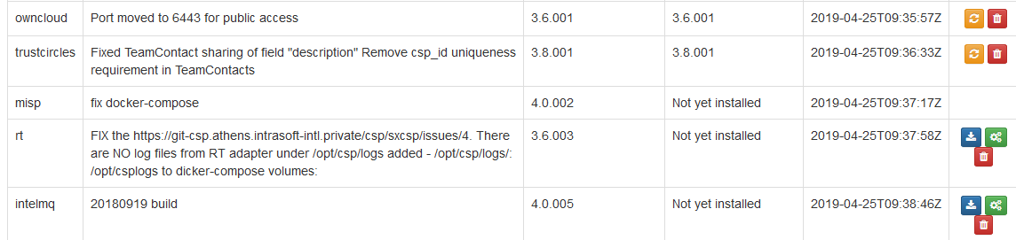

It is suggested that the user proceeds with installation of images in the order presented in the table. After successful installation of all images, the Updates page should appear as follows (all modules have been installed, only re-install or deletion is possible).

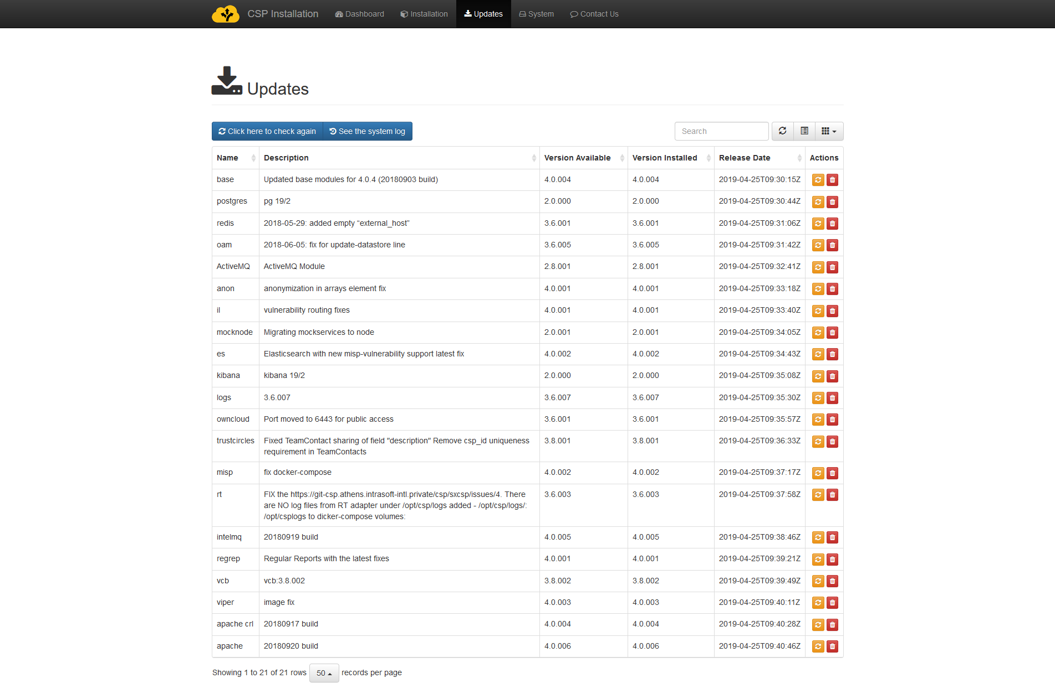

All available images should be installed and only after the user reaches the above stage, with all yellow re-install icons appearing in the Actions column, should the user proceed to the next step which is available in the System page.

# Managing CSP

## Starting

The “system” page shows a current view of the system services registered, together with their current status. The following states are possible:

* Stopped – the service is not currently running
* Running – the service is enabled and running

The column “Can start?” indicates if this is a supporting service or an actual component of the system. Services that indicate the value “No” mean that they do not have a controlling element to start and stop. This is normal for the “base” service in this release.

Current state should be Stopped for all modules the first time this page is accessed.

By clicking the Start button, System start begins. Use the “refresh” button to track progress.

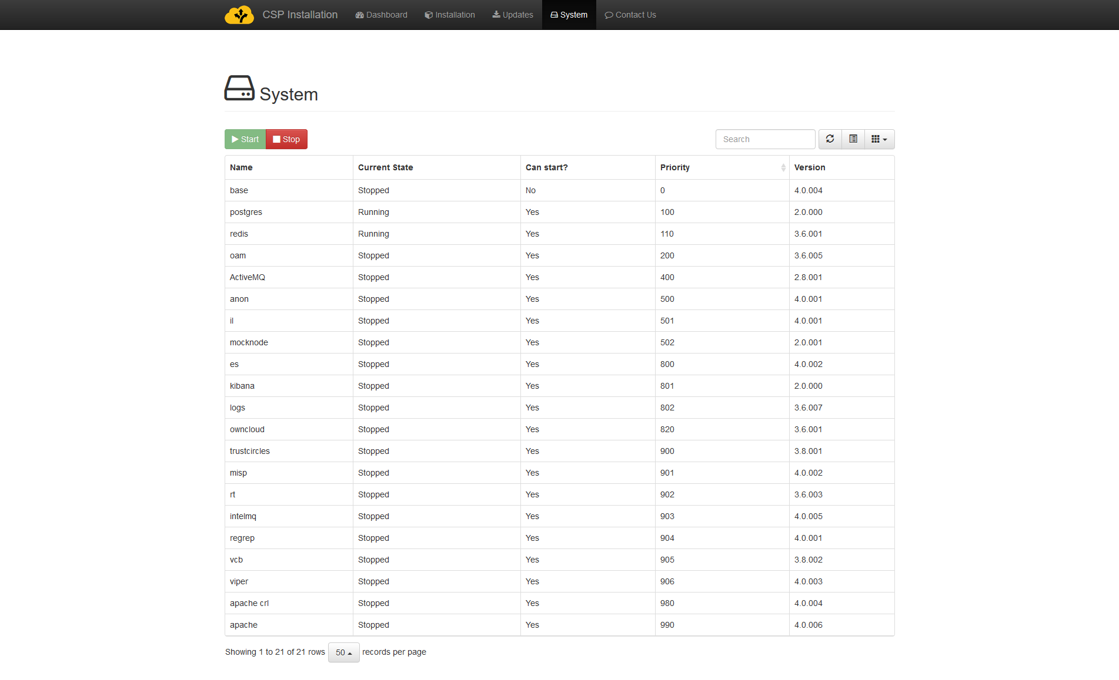

While the system is starting, the Start button is dimmed and only the Stop button is available. The Stop button can be pressed to initiate a System stop, **but not until system has fully started** (all modules – apart base – indicating Running state). Note that due to complexity of services, system Start and Stop are operations that may take a few minutes to complete. Especially system Start is normally expected to last more than 30 minutes to complete, so the user should be patient until all modules report their Running state. During this wait period the user can only refresh the table so as to be informed about the system Start/Stop progress (note that system Stop should not be executed until system has fully started). Modules that have been started will present a “Running” status in the Current State column. The system will start modules in the order displayed in the table.

An anytime the user can navigate to the System Log (available through the Updates page) to watch the system start log entries.

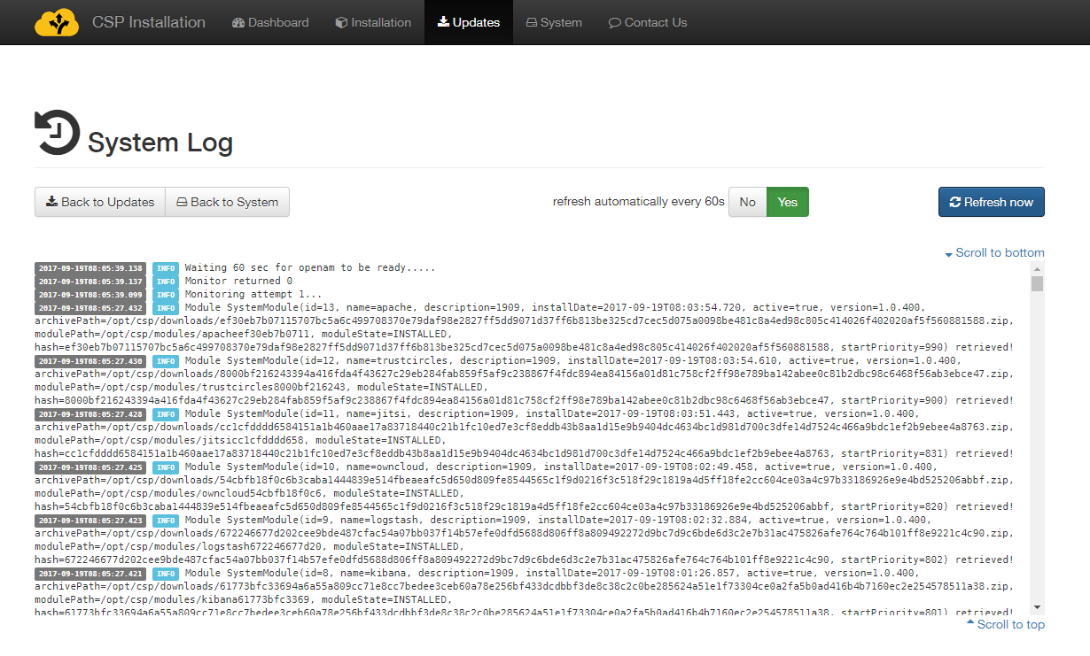

The user should wait until all modules (except Base) report “Running” state. Depending on the performance of the system, the initial start of modules may take more than 30 minutes, due to initialization of security components. Subsequent restarts (if needed) will be much faster. When the system has successfully started, the following should appear.

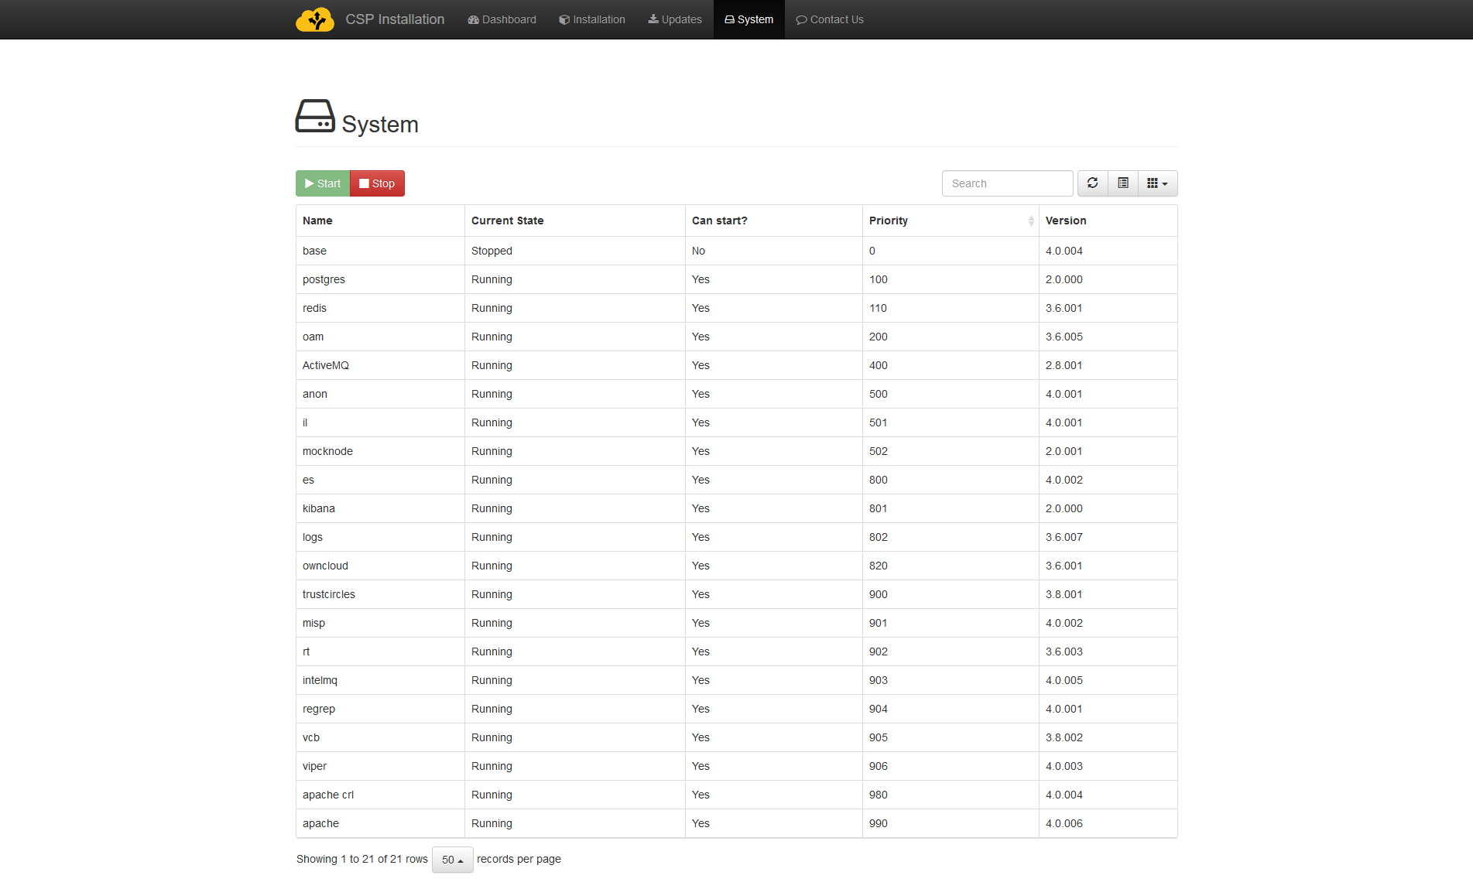

Please note once again that the base module simply contains other module images and is not expected to start so a state of Stopped is expected.

## Stopping

Stopping the system is possible using the “Stop” button. The system shall produce similar output to the “Start” button, and all information provided above is relevant. Note that stopping happens in the reverse order, so the Apache proxy will stop first hence losing access to all applications.

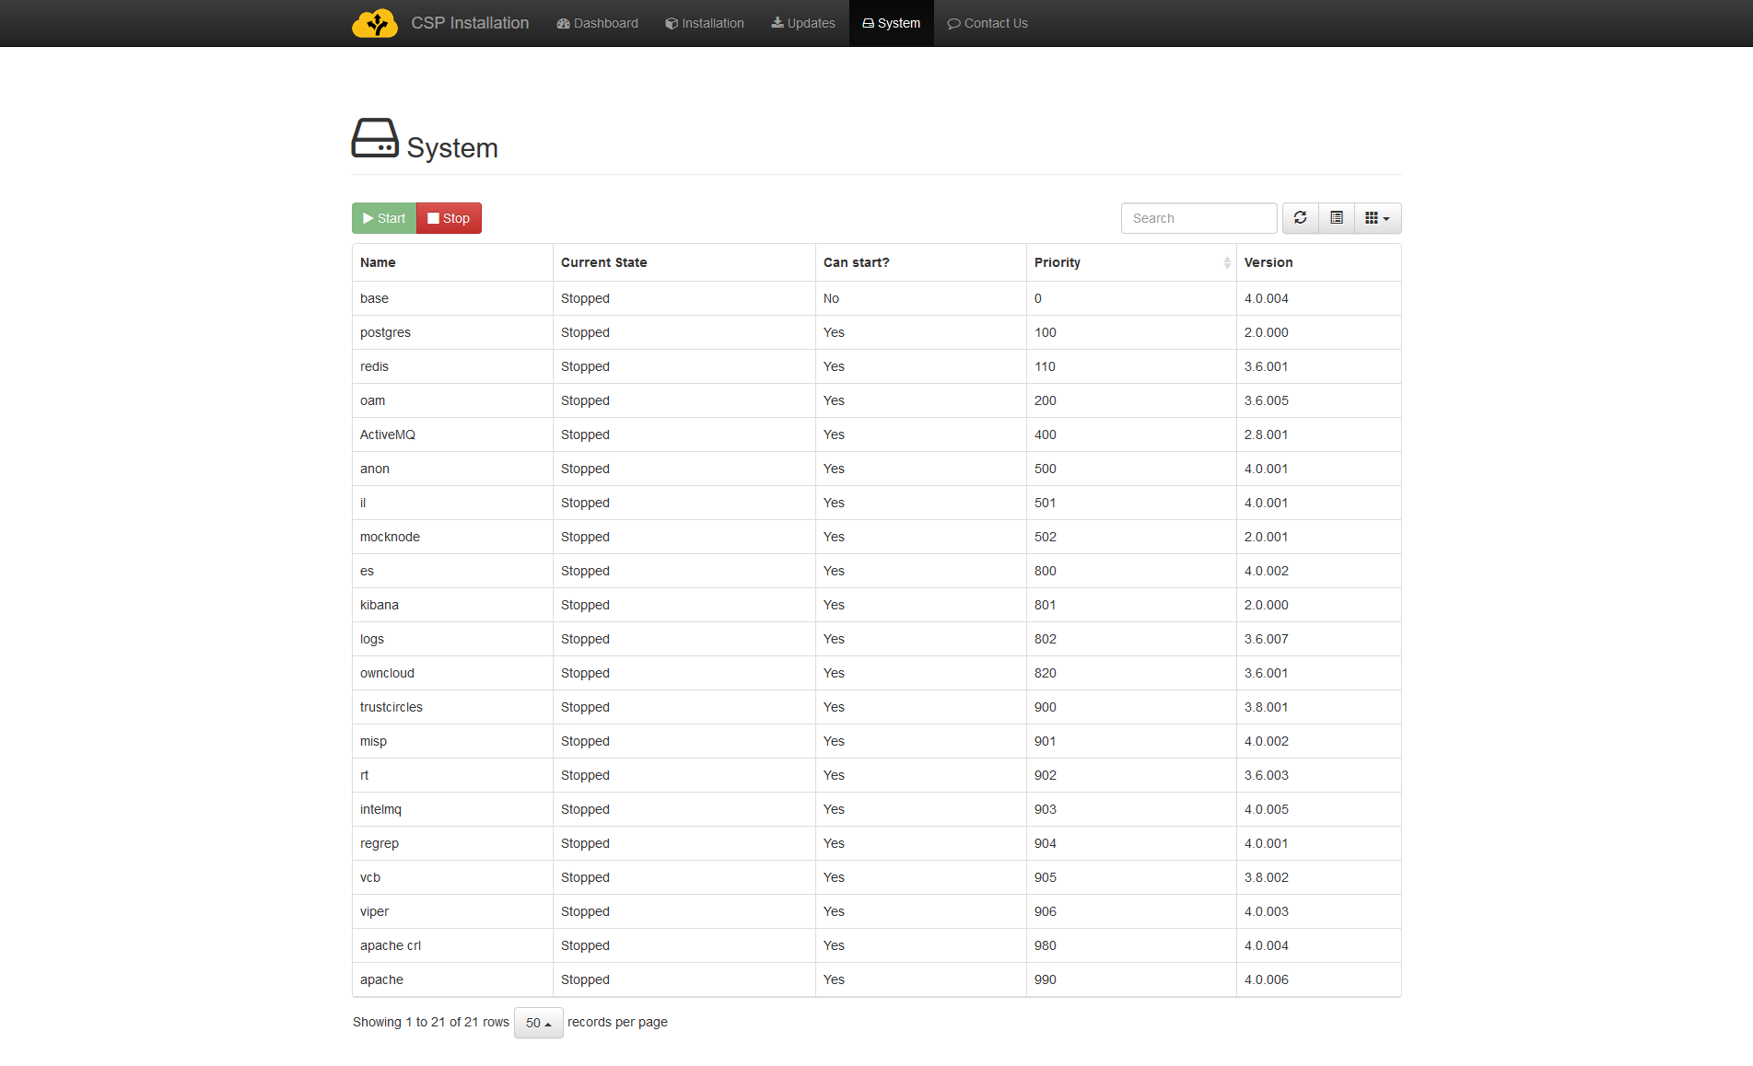

The “Stop” button will *only be available* if at least one service is in “Running” state. Otherwise, (as in the figure above) it will appear disabled.

If a service is start via the console, the installer will not be updated on its status. Therefore, it will be stopped when pressing the “Stop” button. If there, due to installation issues, one or more services have been started manualy, it is a good practice to check that all the services have been stopped correctly when you press the “Stop” button. This check can be done by running “docker ps” in the console, as presented in chapter 7.

## Update SMTP configuration

SMTP configuration provided during registration of the CSP Node can be updated by visiting Installation menu, if system is stopped, as described in previous paragraph. In such case, and when entering Installation menu the installer prompts for SMTP configuration, as shown below:

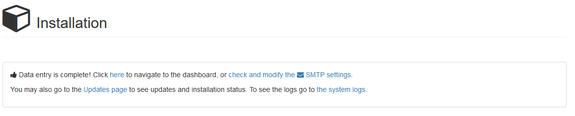

By clicking on the link: “check or modify the SMTP settings” the user is prompted to enter or update the SMTP configuration, as shown below:

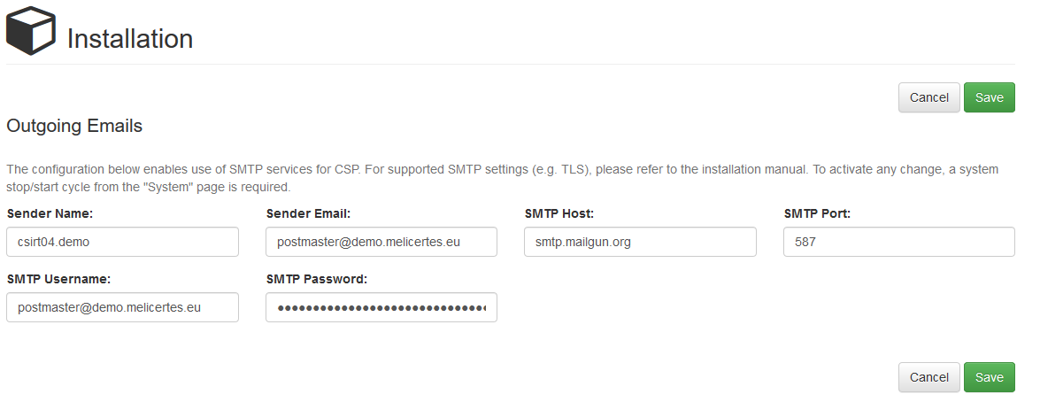

# Smoke-testing the Installation

At this point, the system is ready, and the user should verify connectivity and successful operation of each application.

First check the status of the services via the console. Run the following command

docker stats --all --format "table {{.Name}}\t{{.CPUPerc}}\t{{.MemUsage}}" --no-stream | sort

The output should be similar to the screenshot below

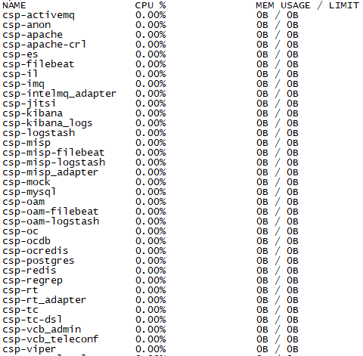

After making sure that **ALL** the docker containers are up and running, you should proceed to check if the application user interfaces are responding. Please see the URLs of web interfaces at the beginning of this manual.

## Connecting via the “Single Sign-on” service

When the user tries to access any application through its web interface, the system will initially try to perform a certificate authentication. If no valid certificate is installed at the user client (or user has cancelled the certificate driven authentication), the system will prompt the user to visit the user authentication page via OpenAM (depending on the browser, the user may need to press “continue” in a system dialog presented).

The following page will indicate that the certificate authentication for the user has failed; OpenAM will indicate that the traditional “username/password” option for login is still available, using the “Return to the login page” link.



By visiting the login page, the user should enter default credentials for authentication (currently demo/changeit). The administrator should change them and/or introduce further users of the platform.

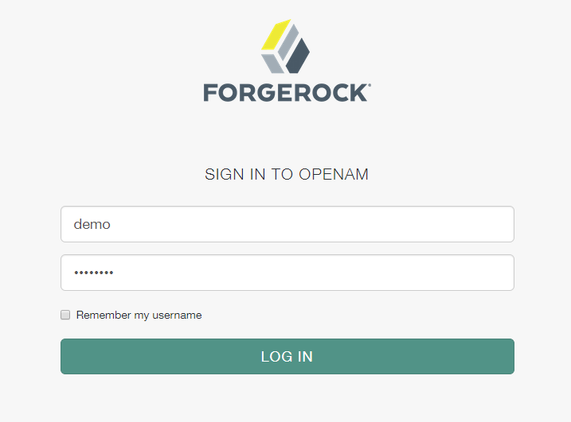

Please note that since the authentication system functions as Single Sign On system, the user will not be prompted again for authentication in each application unless logging out of an application or terminating the session due to time expiration or cookie deletion (e.g. by closing the web browser). Not all web interfaces currently offer a log-out option but in any case this can be performed by visiting the OpenAM web interface.

Also note than when accessing the various web interfaces, an SSL Insecure connection notice may appear due to the existence of self-signed certificates. The user should bypass the warning and proceed.

## Connecting to individual services

The proper operation of all the following services should be confirmed.

**Search: https://search.<cspId>.[preprod.]melicertes.eu**

Navigate to Kibana by entering the above URL to your browser.

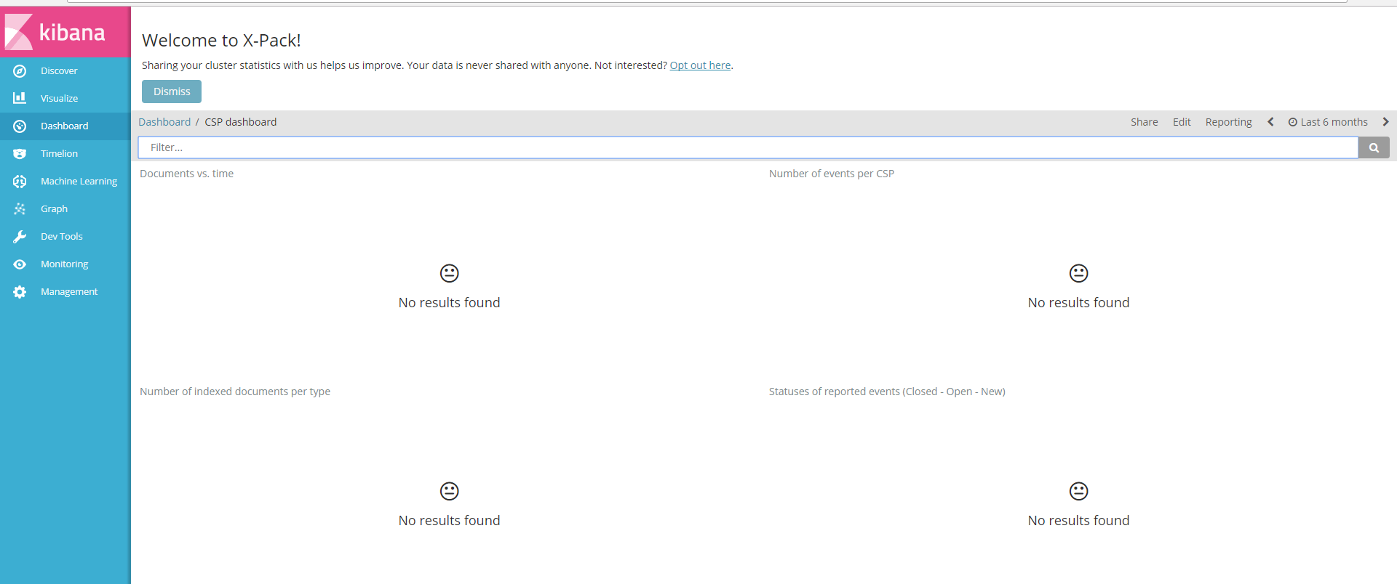

The web interface will display an empty Kibana dashboard. This is normal behaviour for the first time the system is used. Data will appear in the Kibana dashboard as soon as information of the CSP is synchornized.

**Trust Circles: https://tc.<cspId>.[preprod.]melicertes.eu**

Navigate to Trust Circles by entering the above URL to a browser. A page similar to the following should appear and a user as assigned with OpenAM should appear as logged in in the top right corner.

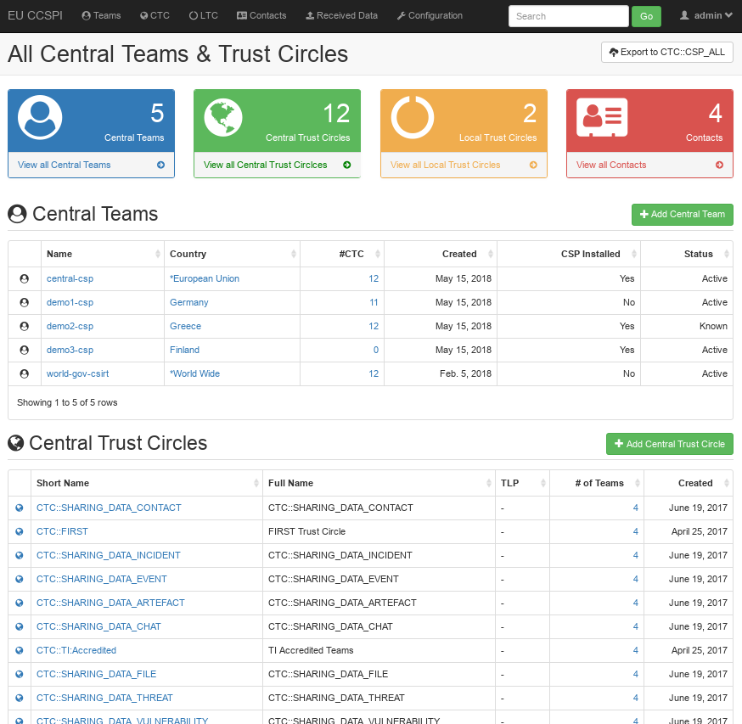

**Contact Management: https://tc.<cspId>.[preprod.]melicertes.eu/local/contacts/teams/**

Navigate to Contact Management by entering the above URL to a browser. A page similar to the following should appear and a user as assigned with OpenAM should appear as logged in in the top right corner.

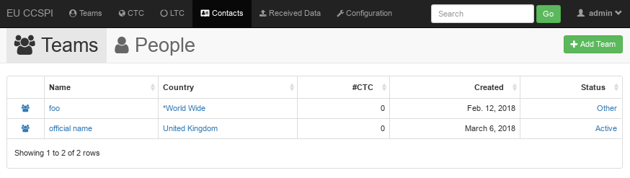

**RT: https://rt.<cspId>.[preprod.]melicertes.eu/RTIR**

Navigate to RT by entering the above URL to your browser.

A page similar to those depicted on the following figure will be displayed and the logged in user will be displayed at the top of the page.

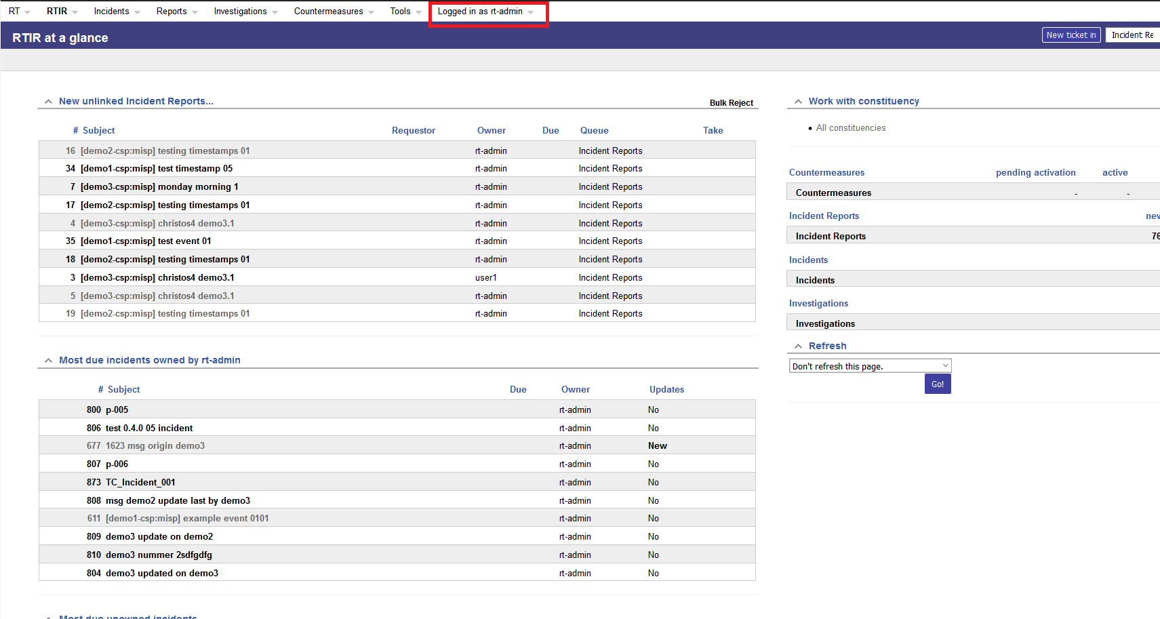

**OpenAM: https://auth.<cspId>.[preprod.]melicertes.eu/openam**

Navigate to OpenAM by entering the above URL to your browser.

A basic user editing information should be displayed.

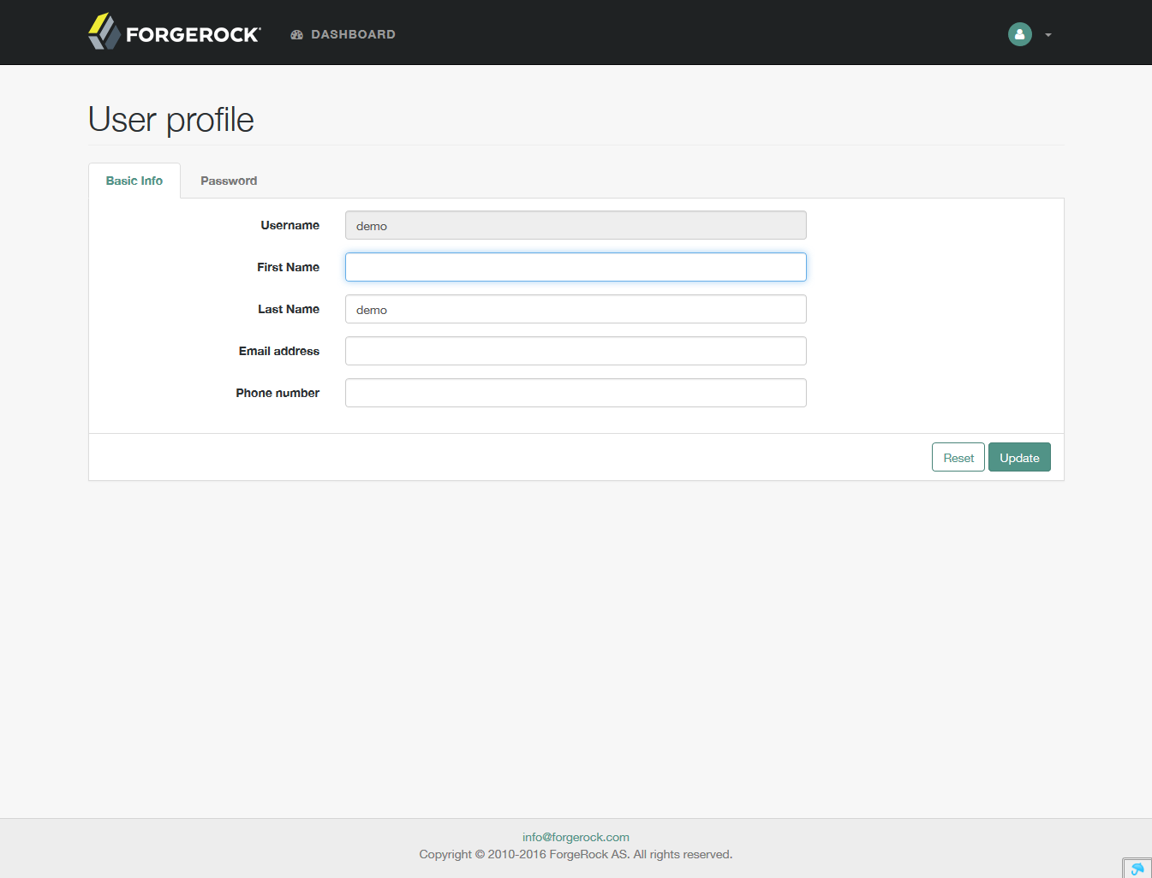

**Sharing Policies: https://integration-ui.<cspId>.[preprod.]melicertes.eu**

Navigate to Sharing Policies application by entering the above URL to a browser.

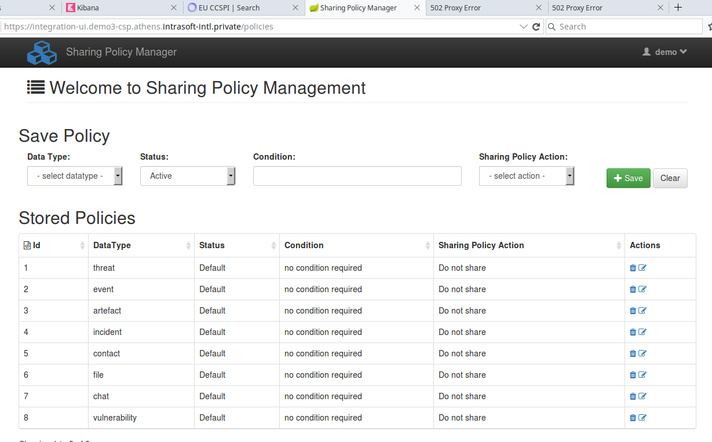

**Anonymization: https://anon-ui.<cspId>.[preprod.]melicertes.eu**

Navigate to Anonymization application by entering the above URL to a browser.

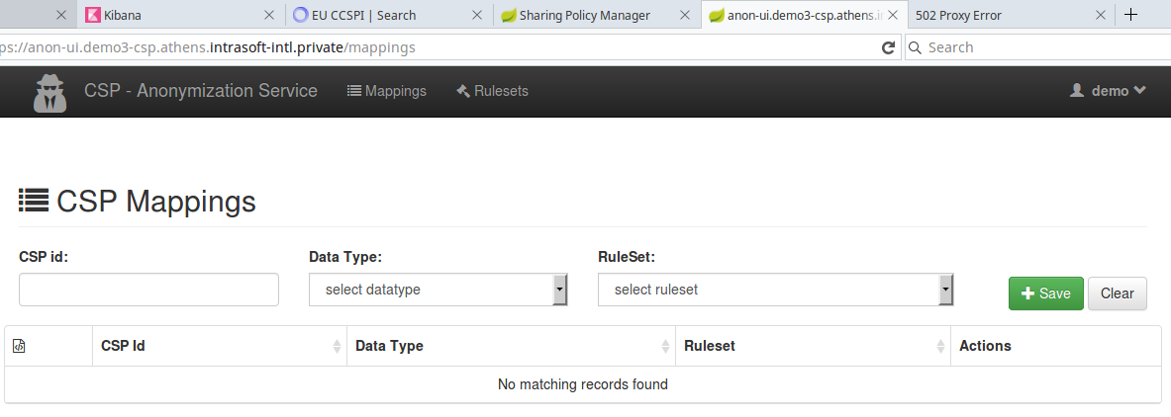

**Logs: https://logs.<cspId>.[preprod.]melicertes.eu**

Navigate to the log display application by entering the above URL to a browser

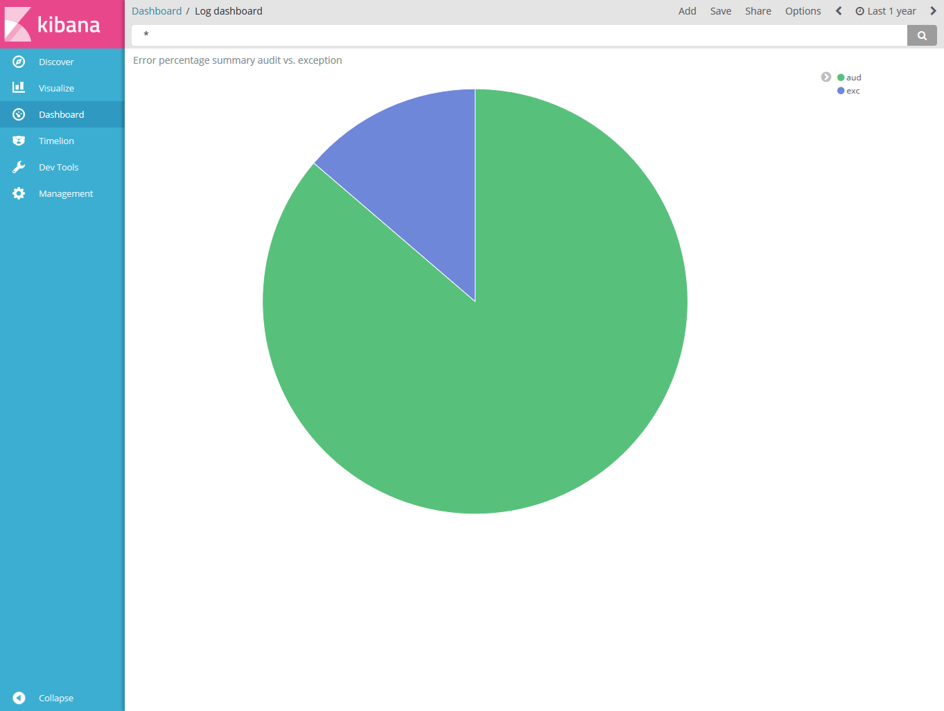

A log dashboard regarding audit and exception logs should be displayed.

**MISP: https://misp-ui.<cspId>.[preprod.]melicertes.eu**

Navigate to the MISP web interface by entering the above URL to a browser

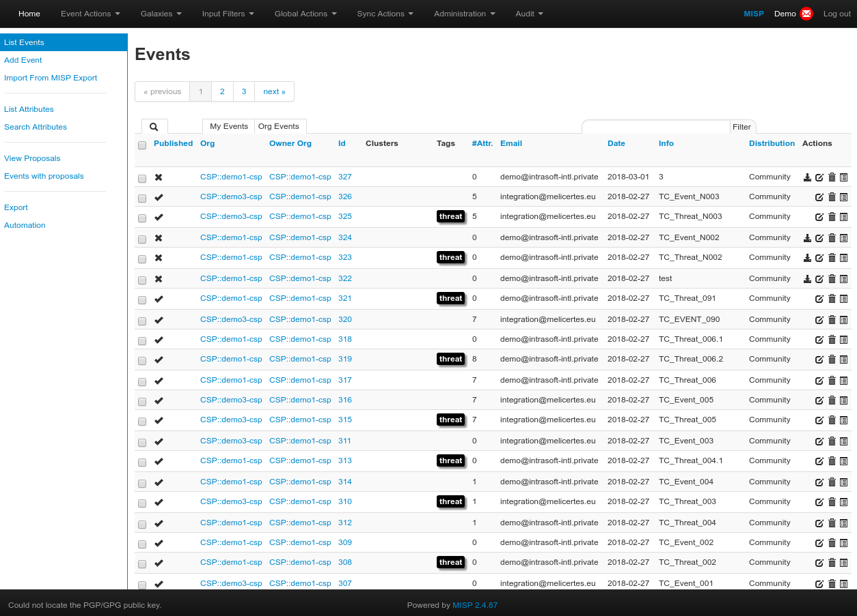

**IntelMQ: https://imq.<cspId>.[preprod.]melicertes.eu**

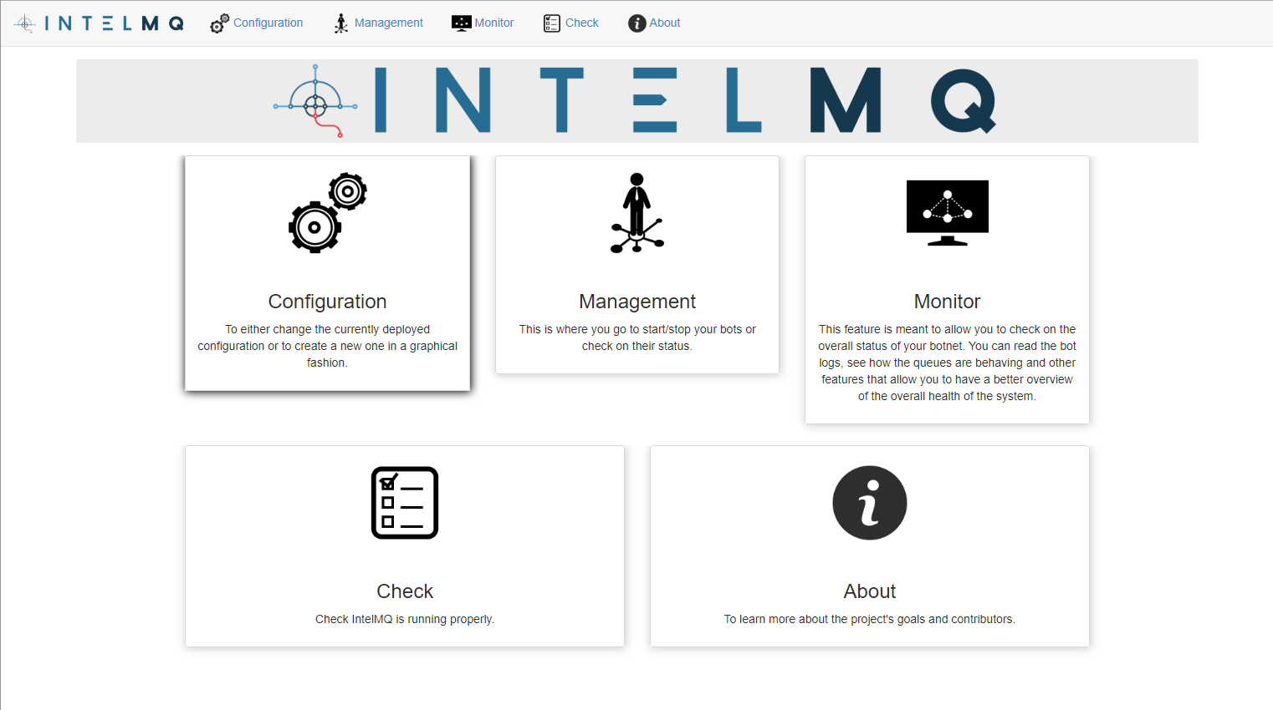

**Owncloud: https://files.<cspId>.[preprod.]melicertes.eu**

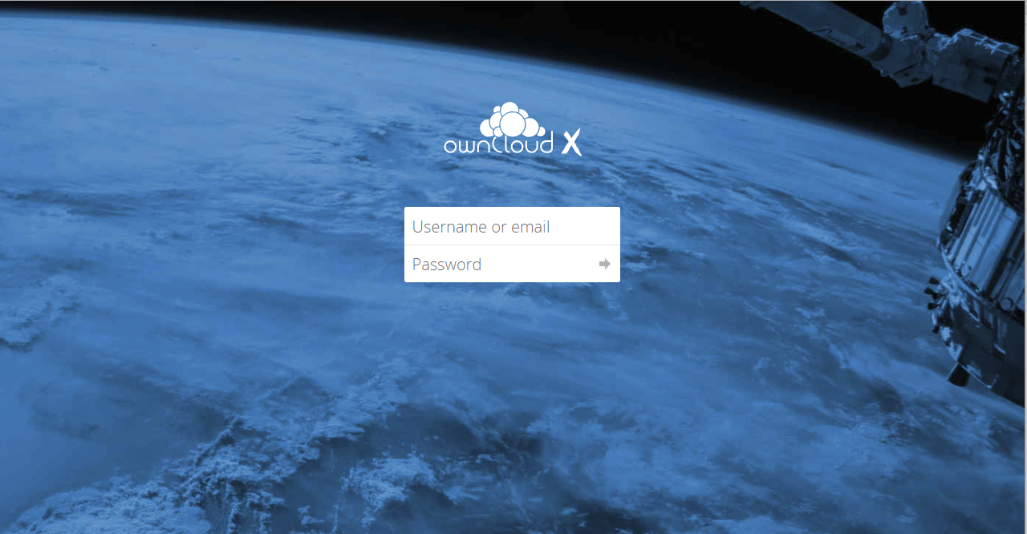

**Videobridge (Jitsi): https://teleconf-ui. <cspId>.[preprod.]melicertes.eu**

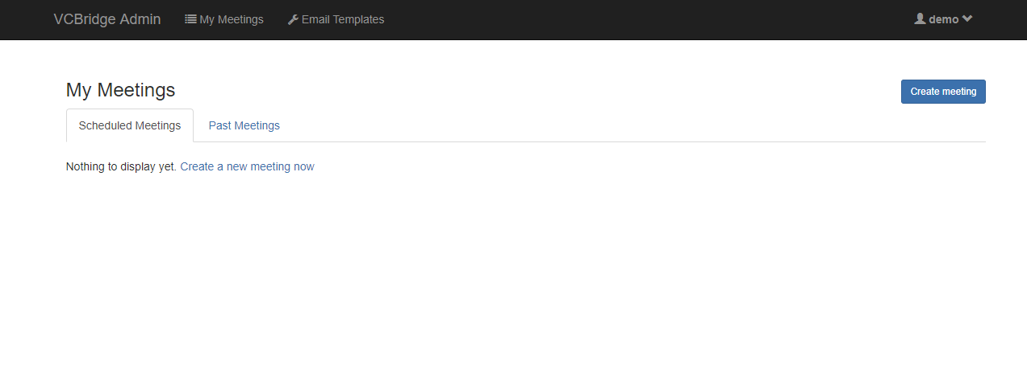

**Viper: https://viper-ui. <cspId>.[preprod.]melicertes.eu**

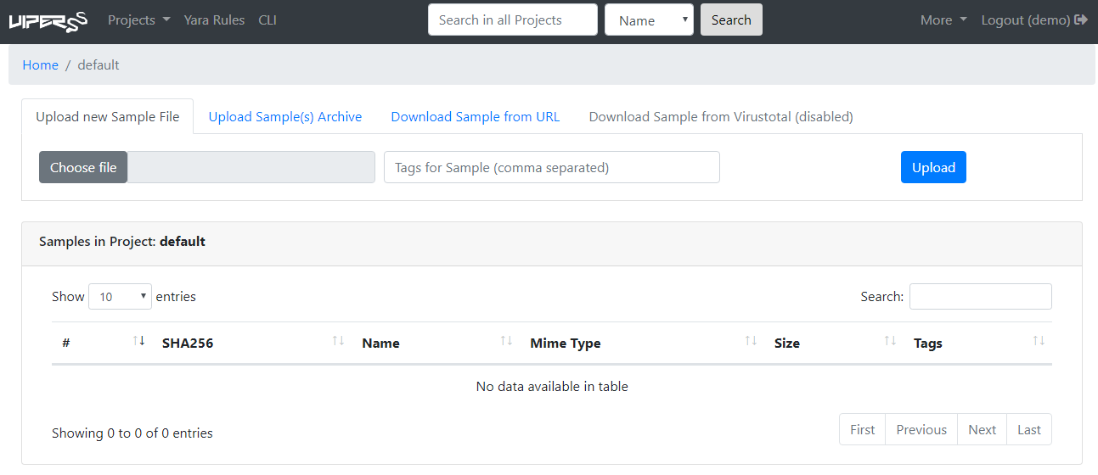

# Annex A: Changing settings of the VM

The virtual machine settings in ESXi allow two operations, prior to booting the machine up:

* Changing of allocated memory: The administrator should allocate at least 24GB (half of recommended) to complete installation and initial CSP sanity tests, using the settings page of the virtual machine.
* Changing of allocated disk: the allocated disk for this VM is too small (16GB) and out of disk is possible. The administrator should allocate 400 GB of fast disk (as per the recommended setup) for the initial period, in a “thin” type of disk (so no pre-allocation). However, this only expands the disk itself, not the underlying filesystem and a reboot will be necessary if the machine is powered on for the change to be made visible. Please check below for instructions to achieve this.

Note: if the machine has already booted, you should shut it down normally (use either the root account or ESXi option) to configure settings.

See the figure below for a typical ESXi 6.0 settings screen (web UI):

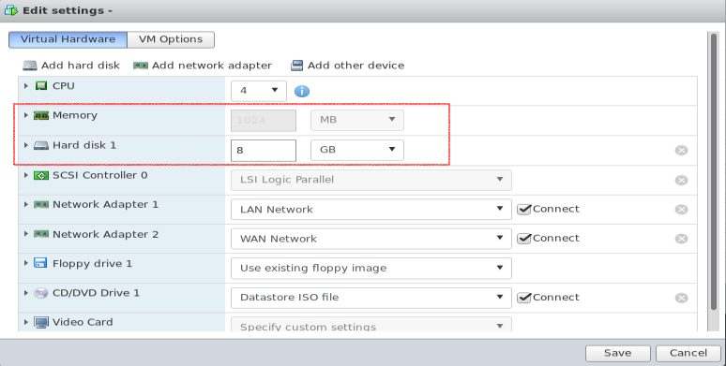

The highlighted part of the settings is the one that needs to be adjusted. Please make sure the adjustments are made when the machine is stopped, otherwise the settings will not be available to be modified.

To complete the adjustment process, follow the next section to expand the file system *within the VM.*

## Expanding the VM root filesystem

The expansion of the filesystem is a two phase process: first phase is to adjust settings (previous section). The next phase is to expand filesystem (this section).

To expand the root filesystem (ext4fs) the following steps are necessary (all items are root commands):

* Check partition size:

|  |
| --- |
| $ df -h /  Filesystem Size Used Available Use% Mounted on  /dev/sda3 40G 913.8M 39,1G 1% / |

* Verify that partition is indeed larger:

|  |
| --- |
| $ dmesg | grep sda #check the output to see new disk size |

* Stop docker services running:

|  |
| --- |
| $ rc-service docker stop |

* Add packages required for this operation:

|  |
| --- |
| $ apk update add parted e2fsprogs-extra |

* Resize partition, using fdisk (note that all commands below after fdisk, are to be entered one after the other:

|  |
| --- |
| $ fdisk /dev/sda   * d * 3 * n * p * 3 * enter * enter * N * w   *With the last one the system should exit fdisk writing changes.* |

* Refresh partition table:

|  |
| --- |
| $ partprobe |

* Resize partition:

|  |
| --- |
| $ resize2fs /dev/sda3 |

* Verify partition is resized:

|  |
| --- |
| $ df -h /  Filesystem Size Used Available Use% Mounted on  /dev/sda3 400G 913.8M 399,1G 1% / |

* Reboot the machine:

|  |
| --- |
| $ sync;sync;reboot |

On reboot of the machine, the system should be ready for installation.

# Annex B: Jitsi VideoConferencing Bridge

The Jitsi VideoConferencing bridge provides a number of features to assist the user in scheduling and conducting a video conference meeting. The following sections discuss the requirements and configuration necessary for successful meetings.

## External port accessibility

The following ports should be available from the internet via either full exposure (e.g. installation in DMZ) or a “Full-Cone NAT” or Symmetric NAT:

* Port 10000, UDP – used for encrypted media (audio/video). This port should be enabled in order to allow low-latency communication;
* Port 4443, TCP – used for encrypted media (audio/video) in case of problems accessing the UDP port.
* Port 6443, TCP – used for the main web interface

**Important note:** If the UDP port is not available, conferences may experience bandwidth and/or latency issues due to the nature of TCP fallback (retransmissions, ack window, etc.).

## Bandwidth requirements

The Jitsi Videoconferencing Bridge implements a “Selective Forwarding Unit[4] – SFU” in Videoconferencing terms. This means that it is scalable and geared towards “asymmetric” links, having more “downstream” bandwidth in the case of a client / participant, and “near” symmetric bandwidth in the case of the bridge itself. Technically the bridge requires as much bandwidth as necessary to be able to receive all streams from all participants and then N times as much to be able to distribute all the received streams to all participants.

A full example for a HD conference (720p) is shown below:

* The audio stream consumes about 50 Kbps (average) for each participant;
* The video stream consumes about 500 Kbps (average) for a combined audio/video total of 550 Kbps per participant.
* For a conference with 5 endpoints (N = 5), the theoretical bandwidth required would be:
  + Clients:
    - Send: 550 Kbps (one video and one audio channel)
    - Receive: 550 x (N - 1) = 550 x 4 = 2200 Kbps (video/audio from 4 participants)
  + Server (bridge):
    - Receive: 550 x N = 550 x 4 = 2200 Kbps (Bridge receives N participant audio/video streams)
    - Send: 550 x (N) x (N - 1) = 550 x 5 x 4 = 11000 Kbps (Bridge transmits 4 audio/video streams to each of 5 participants, each participant does not receive back his/her own stream)

However, there are optimization techniques used that make the bandwidth requirements much less:

* *Available Bandwidth detection* – Jitsi actively monitors latency of the links and bandwidth availability; in cases of reduced bandwidth, video quality may be lowered, or video stopped completely.
* *Use of “Simulcast”* – a browser feature that allows various levels of quality for a video stream to be concurrently streamed from a client, allowing the bridge to decide based on bandwidth calculations whether to forward an HD / SD / LD stream to other participants.
* *Use of “Last-N”* active speakers – using activity detection, the bridge only forwards video/audio of the “Last-N” active speakers instead of everyone to everyone.

To conclude, the numbers for the above calculation can be considered as the absolute maximum, for 5 participants and HD video.

# Annex C: Troubleshooting CSP Installer

In case you experience errors in accessing CSP applications after the completion of the CSP installation, in this chapter you may find specific steps to follow, especially for HTTP Error Code 403 (Forbidden) when requesting a CSP applicarion UI.

To resolve the situation you have to connect to the CSP VM via SSH as described earlier in this manual.

At this point you have to make sure that the installation of the CSP Installer application has successfully created all the required OpenAM and Apache web agents for accessing any available CSP application.

Checking the creation of OpenAM web agents:

In your terminal execute the command:

* fgrep "ACTIONS COMPLETED" /tmp/spring.log

If all OpenAM web agents have successfully created the output should contain the following lines (indicating true in all services):

ACTIONS COMPLETED: OAM : true - APC : true for service ActiveMQ

ACTIONS COMPLETED: OAM : true - APC : true for service anon

ACTIONS COMPLETED: OAM : true - APC : true for service il

ACTIONS COMPLETED: OAM : true - APC : true for service kibana

ACTIONS COMPLETED: OAM : true - APC : true for service logs

ACTIONS COMPLETED: OAM : true - APC : true for service trustcircles

ACTIONS COMPLETED: OAM : true - APC : true for service misp

ACTIONS COMPLETED: OAM : true - APC : true for service rt

ACTIONS COMPLETED: OAM : true - APC : true for service intelmq

ACTIONS COMPLETED: OAM : true - APC : true for service vcb

ACTIONS COMPLETED: OAM : true - APC : true for service viper

In other words, the complete output of the abobe command should look like:

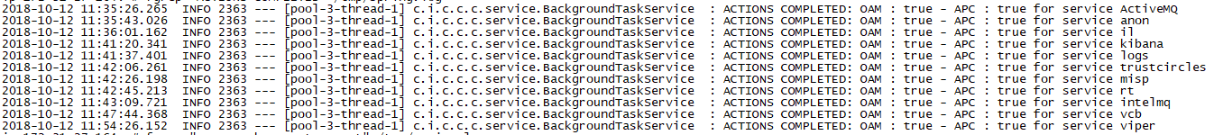

In case one or more from the above listed lines is missing from your terminal you have to execute the following command (one time per missing line):

* docker exec -it csp-oam script /dev/null -c "create-agent.sh {ITEM}"

where {ITEM} represents the missing item and can be one of the following:

* activemq
* anon-ui
* integration-ui
* search
* logs
* tc
* misp-ui
* rt
* imq
* teleconf-ui
* viper-ui

# Annex D: Troubleshooting the connection tunnel to the VM

The initial start of a VM does several checks, including an auto-update check that may take a significant amount of time. However, the installer process is setup to automatically restart, and it will eventually do so.

You are always able to check that the CSP Installer process is running by issuing the following command on the VM terminal:

* ps -ef | grep cspinst

Normally, and provided that the CSP Installer is running and its start-up has been completed, the output of the previous command should look like:

* cspvm [~]# ps -ef | grep cspinst
* 2170 root 0:00 grep cspinst
* 32135 root 0:00 /bin/bash -c /opt/cspinst/cspinstaller.sh >/tmp/console.log 2>&1
* 32136 root 0:00 bash /opt/cspinst/cspinstaller.sh
* 32149 root 0:00 {cspinstaller.ja} /bin/bash ./cspinstaller.jar
* 32166 root 109:35 /opt/cspinst/java/bin/java -Dsun.misc.URLClassPath.disableJarChecking=true -jar /opt/cspinst/cspinstaller.jar

Additionally, you are able to check that the tunnel to port TCP/18080 has been opened, thus you will be able to access CSP Installer’s web interface, by issuing the command:

* netstat -tnl | grep 18080

In case tunnel to port TCP/18080 has been opened, you should see a single line, with "LISTEN" at the end, as follows:

* cspvm [~]# netstat -tnl | grep 18080
* tcp 0 0 ::ffff:127.0.0.1:18080 :::* LISTEN

# Annex E: Manual Installation and configuration of the CSP Installer

*This Annex describes the process of configuring CSP Installer in a clean Alpine Host and is* ***obsolete****.*

*OVA files that are delivered from CSP Central in production (prod.melicertes.eu) and staging (stage.melicertes.eu) environments already include the configuration described here.*

*What is described here is applicable if CSP Helpdesk requires that you install manually a new installer.*

Before installing a CSP Node a set of certain steps have to be taken so as to properly configure the CSP Installer daemon which will in turn communicate with the Central CSP Server and acquire applications, updates, etc.

Prerequisities for the pre-installation steps mentioned in this paragraph are:

* You have configured your network according to guidelines reported in chapter 2 of this manual
* You have ensured SSH access to the CSP Node, as described in previous chapter
* You have obtained an image of the CSP Installer application, i.e. a file named: CSP-VM-installer-v1.tgz

**STEP 1**

From your terminal run the following command to upload the CSP Installer’s tarball to the /tmp directory of the CSP VM:

* scp CSP-VM-installer-v1.tgz root@<guestmachinehostname>:/tmp

Alternativelly, you may use an SFTP client application of your choice, i.e. FileZilla.

After uploading the compressed tarball file, execute the following command to extract its contents and ensuring that /opt directory is present on the VM:

* cd /tmp
* tar -zxvf CSP-VM-installer-v1.tgz
* mkdir -p /opt

**STEP 2**

At this point you are ready to start the installation of the CSP Installer as follows:

* sh install.sh

Let the script finish and notice/copy the last line of its reponse, that should like:

* tty5::respawn:/bin/bash -c /opt/cspinst/cspinstaller.sh

**STEP 3**

At this step CSP Installer application will be configured to run automatically. To do this we are going to replace the tty5 related line in file /tc/inittab with the one copied from previous step. In details, open /etc/inittab for editing via:

* vi /etc/inittab

Navigate to line starting with tty5 and when the cursor is blinking at the start of the line press keys: **i** and **#**.

Add a line right after this line and paste the copied line from previous step. After the modification the file should look as shown below:

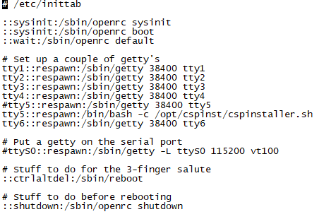

Press keys: **Esc** and the sequence: **wq** to save and exit editor.

**Important Notice:**

It is strongly reccomended for administrative reasons the above line could also include a log file to monitor CSP Installer’s activity. If such functionality is desired, then the line should be entered as follows:

* tty5::respawn:/bin/bash -c "/opt/cspinst/cspinstaller.sh >/tmp/console.log 2>&1"

assuming that /tmp/console.log is the desired log file.

**STEP 4**

Configure CSP Installer daemon with the proper DNS entries, regarding your Central CSP Node. To do this you have to edit file /opt/cspinst/cspinstaller.sh as follows:

* vi /opt/cspinst/cspinstaller.sh

Edit lines 10 and 11 to configure the correct CSPHOST and CSPCONFUI parameters. An example is shown below:

CSPHOST="central.{YOUR-CSP-environment.}melicertes.eu"

CSPCONFUI="config.central.{YOUR-CSP-environment.}melicertes.eu"

Where,{YOUR-CSP-environment.} is the DNS preffix of your CSP installation in the melicertes.eu ecosystem.

**STEP 5**

At this point you have to upload and insert the Root Certificate obtained via the process described in chapter 3 of this manual (and specifically in paragraph 3.5). Uploading can be done by executing in your terminal:

* scp CA_Bundle.crt root@<guestmachinehostname>:/opt/cspinst/jdk1.8.0_144/jre/lib/security/

assuming that the certificate obtained from paragraph 3.5 is named: CA_Bundle.crt. Also, this step can be alternatively performed by using an SFTP client application of your choice, i.e. FileZilla.

After uploading the certificate, execute the following commands:

* cd /opt/cspinst/jdk1.8.0_144/jre/lib/security/
* /opt/cspinst/jdk1.8.0_144/bin/keytool -importcert -file CA_Bundle.crt -keystore cacerts -trustcacerts

When prompted for password you have to enter: **changeit a**nd when prompted for trusting the certificate you have to type: **yes** and hit **Enter**.

**STEP 6**

At this point you have to reboot the VM in order to let the CSP Installer application autostart. Also notice that each time the CSP Installer starts it also checks for updates and execute a self-update procedure.

For information on CSP Installer application troubleshooting you may see Chapter 10 (Annex C: Troubleshooting CSP Installer) of this manual.

- End of document-

1. Version is indicative and is subject to change
2. “bari.test” is a fictional CSIRT domain name used for example purposes
3. Extraction of logs via the web UI is possible: Click within the log window, press “Ctrl + A” or “Cmd + A” if on a Mac, then open a text editor and paste (“Ctrl + V” or “Cmd + V”). Save the file and attach it to a ticket or email to support.
4. See <https://jitsi.org/jitsi-videobridge-performance-evaluation/> and <https://webrtcglossary.com/sfu/> for SFU explanation